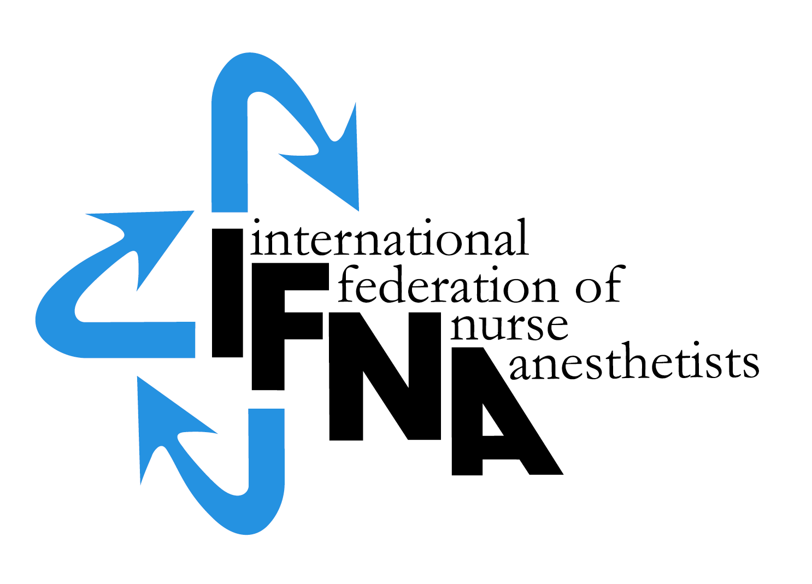

ELIGIBILITY APPLICATION
FOR NURSE & NON-PHYSCIAN ANESTHESIA
PROGRAM RECOGNITION

by the

International Federation of Nurse Anesthetists’ (IFNA)
Education Committee on Behalf of IFNA

Introduction:

The International Federation of Nurse Anesthetists (IFNA) is a global organization representing the specialty of nurse anesthetists.

IFNA has developed a program approval process with three categories of approval. Programs are to apply for only one category. This application is to determine eligibility for IFNA Recognition, which includes a pledge for the program to meet the IFNA Educational Standards for Preparing Nurse Anesthetists to the best of its ability. The pledge includes the signature of the anesthesia program director and the highest institutional official. The program is also required to submit its curriculum and related material for review by the IFNA Education Committee. After the program is notified that it is eligible for recognition, the curriculum will be audited to determine if it substantially complies with the “Content of Program Curriculum” in the Educational Standards. Following a successful auditing process, the program’s identity, title of award and curriculum will be posted on IFNA’s website with a statement that IFNA has audited the curriculum and determined it substantially meets its requirements. Title of certificate awarded: IFNA Anesthesia Education Program Recognition.

Instructions:

A copy of IFNA’s Educational Standards for Preparing Nurse Anesthetists and IFNA’s Anesthesia Program Approval Process (APAP) Operational Policies and Procedures are available on IFNA’s website. It is strongly recommended that the Educational Standards and policies and procedures be reviewed prior to the completion of this form.

Anesthesia programs applying for registration by IFNA are requested to complete this form. When submitting the form to the IFNA Executive Office, it should be accompanied by appropriate documentation to support what is said about the program in the application. For example, copies of course descriptions are to be submitted in support of a written description of the curriculum. The application form requires the name of the Program Director who will be the contact for IFNA in the processing of the application.

- It is requested that the completed “IFNA Eligibility Application for Nurse & Non-Physician Anesthesia Program Recognition” form be submitted by e-mail to the IFNA Executive Office at ifna.rod@wanadoo.fr. The following items are to be submitted when seeking eligibility for IFNA Registration status:

- A completed IFNA Eligibility Application form.

- Information about the program’s curriculum as follows:
  - Admission requirements
  - Course Titles
  - Length of Program
  - Degree or certificate awarded to graduates

- Please submit all of the items on this list to the IFNA Executive Office at ifna.rod@wanadoo.fr.

Note to Applicant Programs for IFNA Recognition:

You will be notified if your program is, or is not, eligible to seek IFNA Recognition or if additional information is needed. Eligible program will be notified to submit information to undergo an audit to determine if the program substantially complies with the “Content of Program Curriculum” in IFNA’s Educational Standards

Thank you!

IFNA ELIGIBILITY APPLICATION FOR

NURSE & NON- PHYSICIAN

ANESTHESIA PROGRAM RECOGNITION

Name of Applicant Anesthesia Program:
________________________________________________

Information about the Program Director:

Name: ________________________________________________
Title__________________________________________________
Street Address (or P.O. Box) _______________________________
__________________________________________________________________________________________________________
Code: ______________City________________________________
Country_______________________________________________

Telephone: (Country Code, City Code and number)
Home: _____________________________
Work: ______________________________
Fax: (please indicate if number is home or work)
___________________________________
E-mail address: (if available) _______________________

If there is no telephone or fax number, please list a name and number of an alternate contact (include Country Code, City Code and number)
Telephone: _______________________
Fax:___________________________

- IFNA Educational Standards and Program Approval Policies

  - The goal of IFNA’s approval process is to encourage programs to comply with IFNA’s Educational Standards for Preparing Nurse Anesthetists through an approval process that takes cultural differences into consideration. Please review the enclosed IFNA Educational Standards for Preparing Nurse Anesthetists and the IFNA Anesthesia Program Approval Process (APAP) Operational Policies and Procedures manual prior to submitting this application to determine if your program is eligible for recognition and willing to meet the requirements.

  - Does your anesthesia program (the applicant program) meet requirements to be considered for recognition?

    - Does the anesthesia program only educate non-physicians?
      - Yes____
      - No___

    - How many nurses and other types of students are enrolled in your program?
      - Nurses (#)_____
      - Others (#) _____

    - Does the anesthesia program have admission requirements that include an education in nursing or another scientific background that prepares a student to succeed in the anesthesia program?
      - Yes____
      - No___

    - Does your anesthesia program pledge to meet IFNA’s Educational Standards and program approval policies to the best of its ability?
      - Yes____
      - No___

    - Has the program been denied registration, recognition or accreditation by a governmental or nongovernmental accreditation or quality assurance entity at any time?
      - Yes____
      - No___

- General Information about Education requirements for Entry into Basic Nursing Education and Practice in your country.

  - Briefly describe the educational and other requirements for entry into basic nursing education in your country.

  - What is the minimum age for entry into a basic nursing educational program? ______

  - What are the number of years (or months) required to successfully complete the basic nursing education?
    - 2 years_____or months______
    - 3 years_____or months______
    - 4 years_____or months______

  - Is licensure required to practice as a professional nurse?
    - Yes____
    - No_____
    - If yes, is this by examination
      - Yes____
      - No____
    - If no, how is the nurse recognized as a professional? (Please check (X) all that apply).
      - The Ministry of Health____
      - The Ministry of Education___
      - Other____

- General information about Non-Physician Anesthesia Educational Programs and Requirements in your country.

  - Are there other non-physician anesthesia education programs in your country?
    - Yes____
    - No____
    - If yes, what is the number of schools? ______

  - Are the non-physician programs (Check (X) all that apply.)
    - National____
    - Local_____
    - Regional_____
    - Private____

  - Are the non-physician programs (schools) approved?
    - Yes__
    - No___
    - If yes, by whom are they approved?

  - Is the non-physician anesthesia educational program’s curriculum standardized throughout the country?
    - Yes___
    - No___

National Association

Is there a national non-physician anesthesia organization in your country?

Yes_____

No_____

Official contact person for national association:
Name: ________________________________________________
Title__________________________________________________
Street Address (or P.O. Box) _______________________________
__________________________________________________________________________________________________________
Code: ______________City________________________________
Country_______________________________________________

Telephone: (Country Code, City Code and number)
Home: _____________________________
Work: ______________________________
Fax: (please indicate if number is home or work)
___________________________________
E-mail address: (if available) _______________________

If there is no telephone or fax number, please list a name and number of an alternate contact (include Country Code, City Code and number)
Telephone: ______________________Fax:__________________________

- Information about your Non-Physician Anesthesia Program that is applying for IFNA Recognition (Applicant Program)

  - Briefly describe the educational and other requirements for entry into your non-physician anesthesia educational program. This should include: years of nursing or other experience, type of nursing or other experience required, pre-entry evaluations, testing, dossier, etc. (Please list all of the requirements.)

  - What is the length of the your anesthesia educational program?
    - ______years
    - ______months.

  - Who establishes the standards and educational requirements for your anesthesia educational program?

  - Describe the content of your anesthesia educational program, including the amount of theory and clinical experience. Please include an example of the curriculum including a list of course titles.

  - Please explain any differences between the curriculum for nurse and non-nurse students.

- Credentials
  - What type of credential is offered upon successful completion of the applicant non-physician anesthesia educational program?
    - Certificate_____
    - Diploma_____
    - Degree_____
    - Other_____

  - Is this credential
    - Local______
    - Regional_____
    - National_____

  - Is this credential recognized
    - Yes____
    - No____
    - If yes, by whom is it recognized?

  - Is there a continuing education requirement following completion of the non-physician anesthesia educational program?
    - Yes____
    - No____
    - If yes, briefly explain:

Signature & title of authority responsible for the anesthesia program (Officer in charge):

Signature & title of anesthesia Program Director:

_________________________________________________________________________

Approved: June 2009
Effective: June 1, 2010

