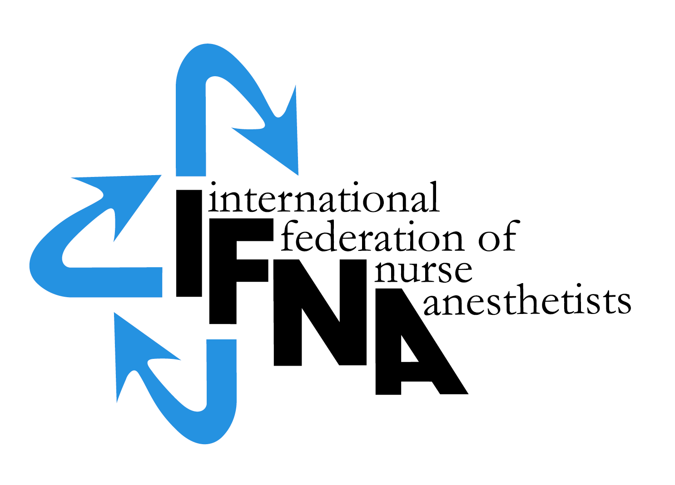

ELIGIBILITY APPLICATION
FOR NURSE ANESTHESIA
PROGRAM ACCREDITATION

by the

International Federation of Nurse Anesthetists’ (IFNA)
Education Committee on Behalf of IFNA

Introduction:

The International Federation of Nurse Anesthetists (IFNA) is a global organization representing the specialty of nurse anesthetists. The IFNA Bylaws (Article VII) definition of Nurse Anesthetist is:

“A nurse anesthetist is a person who has completed a program of basic nursing education and a formal and/or actively pursuing a formal basic nurse anesthesia education and is qualified and authorized in his/her country to practice nurse anesthesia”.

The title “nurse anesthetist” may vary from country to country and the IFNA Council of National Representatives (CNR) recognizes that other titles such as: anesthesia nurse, nurse specialist in anesthesia, advanced practice nursing in anesthesia, etc may be used to define the specialty.

IFNA has developed a program approval process with three categories of approval. Programs are to apply for only one category. This application is to determine eligibility for IFNA Accreditation, which includes a pledge for the program to meet the IFNA Educational Standards for Preparing Nurse Anesthetists to the best of its ability. The pledge includes the signature of the anesthesia program director and the highest institutional official. After the program is notified that it is eligible for accreditation, the program will be asked to submit its curriculum and related material in a written self study for review by the Education Committee. The information will also evaluated by a team of on-site visitors to determine if it meets the Educational Standards. Following a successful accreditation process, the program’s identity, title of award, and curriculum will be posted on IFNA’s website with a statement that IFNA has reviewed the curriculum, reviewed a self study, conducted an on-site visit to the program and determined the program substantially meets all of the Educational Standards. The website will note that the program has substantially met the Educational Standards as determined by a full review of the program including a written self study and on-site review. Title of certificate awarded: IFNA Anesthesia Education Program Accreditation.

Instructions:

A copy of IFNA’s Educational Standards for Preparing Nurse Anesthetists and IFNA’s Anesthesia Program Approval Process (APAP) Operational Policies and Procedures are posted on IFNA’s website at www.ifna-int.org. It is strongly recommended that the Educational Standards and policies and procedures be reviewed prior to the completion of this form.

Nurse anesthesia programs applying for accreditation by IFNA are to complete this form. When submitting the form to the IFNA Executive Office, it should be accompanied by appropriate documentation to support what is said about the program in the application. For example, copies of course descriptions can be submitted in support of a written description of the curriculum. The application form requires the name of the Program Director who will be the contact for IFNA in the processing of the application.

- It is requested that the completed “IFNA Eligibility Application for Nurse Anesthesia Program Accreditation” form be submitted by e-mail to the IFNA Executive Office at ifna.rod@wanadoo.fr. The following items are to be submitted when seeking eligibility for IFNA Accreditation status:

- A completed IFNA Eligibility Application form.

- Information about the program’s curriculum as follows:
  - Admission requirements
  - Course Titles
  - Length of Program
  - Degree or certificate awarded to graduates

- Please submit all of the items on this list by e-mail to the IFNA Executive Office at ifna.rod@wanadoo.fr.

Notification of Eligibility for IFNA Accreditation:

You will be notified if your program is, or is not, eligible to seek IFNA Accreditation. Eligible programs will be instructed to start the self-study process in preparation for an on-site visit.

Thank you!

IFNA ELIGIBILITY APPLICATION FOR

NURSE ANESTHESIA PROGRAM ACCREDITATION

Name of Applicant Nurse Anesthesia Program____________________________

Information about the nurse anesthetist Program Director:

Name: ________________________________________________
Title__________________________________________________
Street Address (or P.O. Box) _______________________________
__________________________________________________________________________________________________________
Code: ______________City________________________________
Country_______________________________________________

Telephone: (Country Code, City Code and number)
Home: _____________________________
Work: ______________________________
Fax: (please indicate if number is home or work)
___________________________________
E-mail address: (if available) _______________________

If there is no telephone or fax number, please list a name and number of an alternate contact (include Country Code, City Code and number)
Telephone: _______________________
Fax:___________________________

- IFNA Educational Standards and Program Approval Policies

  - The goal of IFNA’s approval process is to encourage programs to comply with IFNA’s Educational Standards for Preparing Nurse Anesthetists through an approval process that takes cultural differences into consideration. Please review the IFNA Educational Standards for Preparing Nurse Anesthetists and the IFNA Anesthesia Program Approval Process (APAP) Operational Policies and Procedures manual posted on IFNA’s website prior to submitting this application to determine if your program is eligible for accreditation and willing to meet the requirements.

  - Does your nurse anesthesia program (the applicant program) meet requirements to be considered for accreditation?

    - Does the anesthesia program require that students have completed a basic nursing education program of at least 36 months in length prior to admission?
      - Yes____
      - No___

    - Does the anesthesia program require that students have obtained nursing experience of at least one (1) year, preferably in an acute care setting prior to admission?
      - Yes____
      - No___

    - Does your nurse anesthesia program pledge to meet IFNA’s Educational Standards and program approval policies?
      - Yes____
      - No___

    - Has the program been denied registration, recognition or accreditation by a governmental or nongovernmental accreditation or quality assurance entity at any time?
      - Yes____
      - No___

- General Information about Education requirements for Entry into Basic Nursing Education and Practice in your country.

  - Briefly describe the educational and other requirements for entry into basic nursing education in your country.

  - What is the minimum age for entry into a basic nursing educational program? ______

  - What are the number of years (or months) required to successfully complete the basic nursing education?
    - 2 years_____or months______
    - 3 years_____or months______
    - 4 years_____or months______

  - Is licensure required to practice as a professional nurse?
    - Yes____
    - No_____
    - If yes, is this by examination
      - Yes____
      - No____
    - If no, how is the nurse recognized as a professional? (Please check (X) all that apply).
      - The Ministry of Health____
      - The Ministry of Education___
      - Other____

- General information about Nurse Anesthesia Educational Programs and Requirements in your country.

  - Are there other nurse anesthesia education programs in your country?
    - Yes____
    - No____
    - If yes, what is the number of schools? ______

  - Are the programs (Check (X) all that apply.)
    - National____
    - Local_____
    - Regional_____
    - Private____

  - Are the programs (schools) approved?
    - Yes__
    - No___
    - If yes, by whom are they approved?

  - Is the nurse anesthesia educational program’s curriculum standardized throughout the country?
    - Yes___
    - No___

National Association

Is there a national nurse anesthesia organization in your country?

Yes_____

No_____

Official contact person for national association: (This individual should be a nurse anesthetist with whom the IFNA might contact).

Name: ________________________________________________
Title__________________________________________________
Street Address (or P.O. Box) _______________________________
__________________________________________________________________________________________________________
Code: ______________City________________________________
Country_______________________________________________

Telephone: (Country Code, City Code and number)
Home: _____________________________
Work: ______________________________
Fax: (please indicate if number is home or work)
___________________________________
E-mail address: (if available) _______________________

If there is no telephone or fax number, please list a name and number of an alternate contact (include Country Code, City Code and number)
Telephone: ______________________Fax:__________________________

- Information about your Nurse Anesthesia Program that is applying for IFNA Accreditation (Applicant Program)

  - Briefly describe the educational and other requirements for entry into your nurse anesthesia educational program. This should include: years of nursing experience, type of nursing experience required, pre-entry evaluations, testing, dossier, etc. (Please list all of the requirements).

  - What is the length of your nurse anesthesia educational program?
    - ______years
    - ______months.

  - Who establishes the standards and educational requirements for your nurse anesthesia educational program?

  - Describe the content of your nurse anesthesia educational program, including the amount of theory and clinical experience. Please include an example of the curriculum and a list of course titles.

- Credentials
  - What type of credential is offered upon successful completion of the applicant nurse anesthesia educational program?

    - Certificate_____
    - Diploma_____
    - Degree_____
    - Other_____

  - Is this credential
    - Local______
    - Regional_____
    - National_____

  - Is this credential recognized
    - Yes____
    - No____
    - If yes, by whom is it recognized?

  - Is there a continuing education requirement following completion of the nurse anesthesia educational program?
    - Yes____
    - No____
    - If yes, briefly explain:

Signature & title of authority responsible for the nurse anesthesia program
(Officer in charge):

Signature & title of nurse anesthesia Program Director:

_________________________________________________________________________

Approved: June 2009
Effective: June 1, 2009

