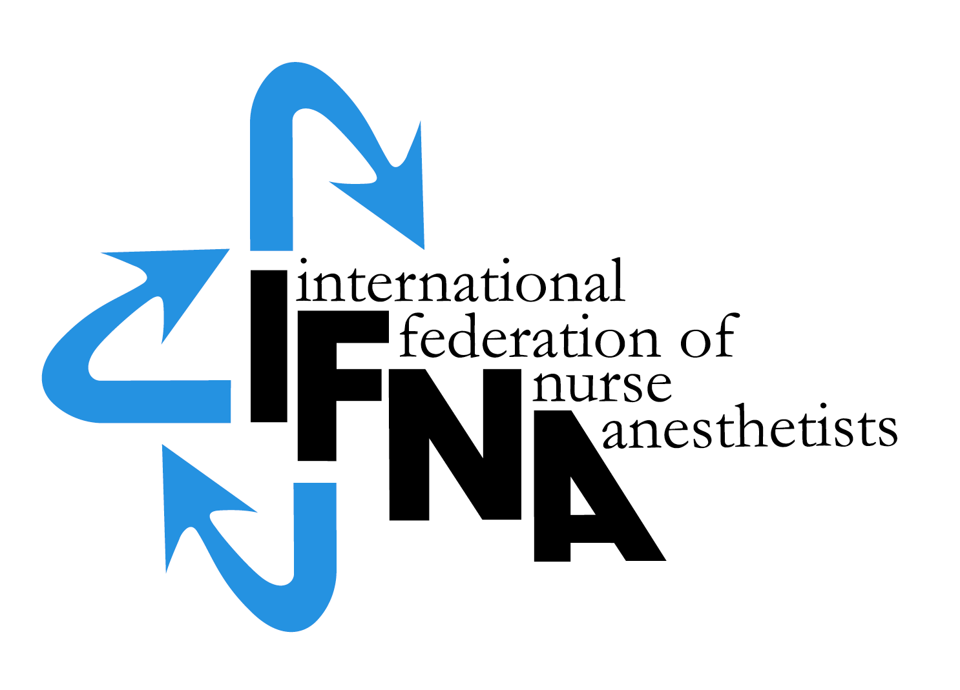

International Federation
of Nurse Anesthetists

Bylaws

Adopted 10 June1989
Revised 10 June 1995
Revised 26 April 1997
Revised 4 August 2000
Revised 3 June 2010
Revised May 2016

Table of Contents Page

Article I Name and Description 3
Article II Philosophy 3
Article III Purpose 3
Article IV Objectives 3
Article V Functions 3
Article VI IFNA Languages 4
Article VII Definition of Nurse Anesthetist 4
Article VIII Membership Associations 4
Criteria for Membership 4
Determination of National 4
Association Membership 4
Regional or Joint Association Membership 4
Duties of Member Associations 4
Withdrawal from Membership 5
Expulsion from Membership 5
Associate Membership 5
Article IX Dues 5
Article X Bodies 5
Article XI Council of National Representatives 6
Composition 6
Functions 6
Meetings 6
Article XII Executive Committee and Board of Officers 7
Functions 8
Meetings 9
Article XIII Executive Director 9
Article XIV Vacancies 9
Council of National Representatives 9
Executive Committee 9
Article XV Committees 10
Appointment 10
Reporting 10
Article XVI Congresses 10
Article XVII Quorum 10
Article XVIII Parliamentary Authority 10
Article XIX Amendments 11
Article XX Dissolution of the IFNA 11
Article XXI Liability 11
Article XXII Governing Law Disputes 11
Article XXIII IFNA Domicile 11
IFNA Definitions 12
International Federation of Nurse Anesthetists (IFNA)

Bylaws

ARTICLE I NAME AND DESCRIPTION

Section 1.

The name of this Federation shall be the International Federation of Nurse Anesthetists, hereinafter referred to as the Federation or the IFNA.

Section 2.

The International Federation of Nurse Anesthetists is a Federation of national nurse anesthetists' associations which have been formally admitted into membership and which have complied with the dues for membership. IFNA is organized and functions unrestricted by consideration of nationality, race, creed, color, politics, sex or social status.

ARTICLE II PHILOSOPHY

The International Federation of Nurse Anesthetists is an international organization of nationally registered nurses with special formal and/or actively pursuing a formal education in nurse anesthesia. The members of this professional organization are dedicated to the precept that its members are committed to the advancement of educational standards and practices, which will advance the art and science of anesthesiology and thereby support and enhance quality patient care.

ARTICLE III PURPOSE

The purpose of the IFNA is to promote assistance in the development of strong national nurse anesthesia associations.

ARTICLE IV OBJECTIVES

1. To promote cooperation between nurse anesthetists internationally.
2. To develop and promote educational standards in the field of nurse anesthesia.
3. To develop and promote standards of practice in the field of nurse anesthesia.
4. To provide opportunities for continuing education in anesthesia.
- To assist nurse anesthetists’ associations to improve the standards of nurse anesthesia and the competence of nurse anesthetists.
- To promote the recognition of nurse anesthesia.
7. To establish and maintain effective cooperation between nurse anesthetists, anesthesiologists and other members of the medical profession, the nursing profession, hospitals and agencies representing a community of interest in nurse anesthesia.

ARTICLE V FUNCTIONS

1. To promote continual high quality of patient care.
2. To serve as the authoritative voice for nurse anesthetists and nurse anesthesia internationally.
3. To provide a means of communication among nurse anesthetists throughout the world.
4. To promote the independence of the nurse anesthetist as a professional specialist in nursing.
5. To advance the art and science of anesthesiology.

ARTICLE VI IFNA LANGUAGES

The official language of the IFNA is English.

ARTICLE VII DEFINITION OF NURSE ANESTHETIST

A nurse anesthetist is a person who has completed a program of basic nursing education and a formal and/or actively pursuing a formal nurse anesthesia education and is qualified and authorized in his/her country to practice nurse anesthesia.

ARTICLE VIII MEMBERSHIP ASSOCIATIONS

Section 1. Criteria for Membership

Within a country, one national nurse anesthetists association or federation of nurse anesthetists or, where neither of these exists, a separate nurse anesthetists section or chapter of a national association composed of other health workers, may become a member of IFNA provided that:

A. Its constitution, regulations or rules define objectives which are not in conflict with Article I, Section 2 or with the purpose and objectives of the IFNA.

B. If the association is a section of another health workers' organization, the section has its own separate regulations which are not in conflict with Article I, Section 2, or with the purpose and objectives of the IFNA.

C. The association is controlled by nurse anesthetists gaining its authority from its members and speaks on nurse anesthesiology matters.

D. The association is the most representative of nurse anesthetists in the country according to the
IFNA definition of nurse anesthetist (Article VII).

Section 2. Determination of National Association Membership.

Each national nurse anesthetist association shall retain the right to define its own membership at the national level, with due regard to Article I, Section 2.

Section 3. Regional or Joint Association Membership

Within a region, where there are more that 1 (one) small group of nurse anesthetists, those nurse anesthetists may form a regional organization for representation within the IFNA. In this instance, none of the small independent nations shall have more than 50 nurse anesthetists and the regional association shall be organized and meet the same criteria as in Article VIII Membership Associations, Section 1. Criteria for Membership. Regional associations shall comply with Article VIII Membership Associations. The regional organization shall be entitled to one official IFNA representative and comply with the responsibilities of Member Associations.

Section 4. Duties of Member Associations

It shall be the duty of every member association:

A. To send to the Executive Office/President the names and addresses of all its officers immediately after their election or appointment.

B. To send to the Executive Office/President a copy of its constitution or regulations and details of all amendments thereto within six months of their adoption.

C. To notify the Executive Office/President on or before January 31 in each year of the number of its members on December 31 of the previous year, and forward to the IFNA its annual dues based on that membership.

D. To report to the Council of National Representatives (CNR) at least once every year and to respond to requests for information from the Board of Officers .

E. To make recommendations to the Council of National Representatives (CNR) regarding amendments to the bylaws, policies or position statements of the IFNA.

F. To pay its full dues as defined in Article IX. Failure of payment will result in loss of privileges, to include voting, eligibility to IFNA elected position, appointment and financial support.

Section 5. Withdrawal from Membership.

A member association not in arrears with its dues may withdraw its membership in the IFNA by giving written notice to the IFNA Board of Officers by December 31, twelve months in advance of withdrawing. Any member association so withdrawing its membership in the IFNA shall receive formal acknowledgement of the Council of National Representatives (CNR) action. The association will relinquish all rights and responsibilities of membership at the end of the twelve month period.

Section 6. IFNA Initiated Withdrawal from Membership and Reinstatement.

In extraordinary circumstances, when the procedure for expulsion from membership has been applied and it has been determined that expulsion is not warranted but the problem of payment of dues to the IFNA is insoluble, IFNA Executive Committee and or Council of National Representatives (CNR) may request a member association to withdraw from membership. IFNA will consider a new application for membership from the association only after determining that the association will be able to fulfill its commitments to the IFNA and the association has paid one year's dues in advance.

Section 7. Expulsion from Membership

A. At any time that the IFNA Council of National Representatives (CNR) believes that a member association has ceased to meet the requirements for membership in the IFNA and therefore may be subject to expulsion, such expulsion shall take place only after:

(1) The President/Executive Committee/Council of National Representatives (CNR) has appointed an impartial committee to investigate the situation and make recommendations.

(2) The member association has received notice in writing from the President of the challenge to its membership and the reasons therefor.

(3) The Council of National Representatives (CNR) has provided the member association an opportunity to present its case in writing and, if desired, to appear before the committee.

(4) Consultation has been provided from the IFNA to the member association on methods to remove the cause for the challenge to its membership.

(5) The Council of National Representatives (CNR) has granted a period of time for the member association to correct the situation, the length of time to be decided by the Council of National Representatives (CNR)

(6) A two-thirds (2/3) vote of the Council of National Representatives (CNR) present and voting by referendum recommends the expulsion of the member association.

B. If a member association shall fail to pay its full dues for two (2) successive years without reasonable explanation acceptable to the Council of National Representatives (CNR), the member association shall be formally notified by the President that expulsion proceedings (in accordance with above clauses) have been initiated.

Section 8 Associate Membership

A. Associate Members

1. Non-nurse anesthesia provider organizations may apply for associate membership in the IFNA. Such members may participate at meetings of the IFNA Council of National Representatives (CNR) as an observer with the right to speak but with no voting privileges.

2. Dues for associate membership are one-half (1/2) of regular membership dues. Payment of dues are the same as outlined in Article IX. Dues of the IFNA Bylaws.

ARTICLE IX DUES

Section 1.

A. The annual dues for all member associations shall be based on their annual active membership as of December 31 of the previous year and shall be stated in the currency of the country in which IFNA Headquarters is situated.

B. All dues shall be paid in advance by March 15th in each year.

C. Membership privileges are dependent upon the dues payment and determined by the dues policy.

Section 2.

A. Payment of dues for new member associations for the year of their acceptance is determined in the dues policy as Applicant membership.

B. Payment must be made within 30 days after notification of acceptance into membership.

Section 3.

A. In addition to membership dues, the IFNA may accept donations and legacies as well as grants.

ARTICLE X BODIES

The bodies of the Federation are the Council of National Representatives (CNR), the Executive Committee and the Board of Officers.

ARTICLE XI COUNCIL OF NATIONAL REPRESENTATIVES

Section 1. Composition

The Council of National Representatives (CNR) of the IFNA shall consist of one (1) representative from each full member association who meets the IFNA definition of nurse anesthetist.

A. The representative may be elected or appointed by their member association.

B. Unless procedures provide otherwise, the term of the IFNA National Representative shall be at least 4 years.

C. A representative who is unable to attend a meeting of the Council of Country Representatives (CNR) may be represented by a proxy provided the proxy is:

(1) A nurse anesthetist who meets the IFNA definition of nurse anesthetist.

(2) A member of the same member association for whom the nurse anesthetist is serving as proxy or a member of another IFNA member association.

Section 2 Functions.

The functions of the Council of National Representatives (CNR) shall be:

A. To establish policies including privileges and priorities to fulfill the objectives of the IFNA.

B. To expel member associations from IFNA membership.

C. To elect the Board of Officers and Executive Committee of the IFNA.

D. To approve the dues policy.

E. To receive and act upon recommendations from member associations, officers and committees of the IFNA.

F. To determine changes in the composition and representation in the Council of National Representatives (CNR) Executive Committee/ Board of Officers.

G. To act upon amendments to the Bylaws proposed by the Council of National Representatives (CNR) officers, committees and member associations.

- To approve upon a time and place for holding regular and special meetings of the Council of National Representatives (CNR), as suggested by the President and Executive Director.
Section 3. Meetings.

A. Meetings of the Council of National Representatives (CNR) shall be at least every two (2) years. The meeting during the year of the World Congress shall be held at the time of the World Congress.

B. Special meetings of the Council of National Representatives (CNR) shall be held as deemed necessary by the Council of National Representatives and/or Executive Committee and shall be called by the President upon written requests of at least one third (1/3) of the member association representatives.

C. Voting at meetings of the IFNA Council of National Representatives (CNR) shall be by show of hands except when a majority of those present and voting request a secret ballot. (One vote per representative unless that representative is a proxy for another National Representative.)

D. The general secretaries, association president or deputy may participate in the meetings of the CNR but have no voting privileges unless acting as proxy for the member representative.

E. A majority vote shall consist of more than one-half (1/2) of the votes cast by the members of the Council of National Representatives (CNR) who are present and voting. Abstentions shall be excluded from the total from which the majority is calculated.

F. Business which requires immediate action by the Council of National Representatives (CNR) may be conducted by the Executive Committee and/or the Board of officers by mail and/or telephone and is subject to ratification by the Council of Nation Representatives (CNR) at its next meeting.

ARTICLE XII EXECUTIVE COMMITTEE AND BOARD OF OFFICERS

Section 1.

The Board of Officers of the IFNA, who must be nurse anesthetists and who must remain in good standing in their member association, shall be: a President, 1st Vice President, 2nd Vice President and a Treasurer.

Section 2.

The Executive Committee shall be composed of the Board of Officers and six (6) national representatives.

Section 3.

Officers and members of the Executive Committee shall be elected by majority vote of the Council of National Representatives (CNR)

Section 4.

The Board of Officers and members of the Executive Committee shall be elected every 2 years and may serve successive terms.

Section 5.

The President shall preside over all meetings of the Council of National Representatives (CNR), the Executive Committee and the Board of Officers and be an ex-officio member of all committees. The 1st Vice President shall assume all the duties of the President in the President's absence or inability to serve. In addition, the officers and Executive Committee shall perform those duties incident to their offices and those duties prescribed from time to time by the Council of National Representatives (CNR)

Section 6. Functions of the Board of Officers and Executive Committee.

The Executive Committee shall:

A. Receive information on and approve the budget.

B. Provide for an annual audit.

C. Provide for the safeguarding of IFNA funds.

D. Authorize official IFNA publications.

E. Appoint not less than two (2) nor more than four (4) Representatives /IFNA Members, two (2) of whom shall be the President and one (1) other officer, in whom the properties of the IFNA shall be vested and shall act as the Finance Committee.

F. To approve committee members appointments and to receive and take action on reports of all committees.

- To decide upon the time and host association of the World Congress.

Section 7.

The Board of Officers shall:

A. Act in emergencies between meetings of the Executive Committee.

B. Transact business between Council of National Representatives (CNR) and Executive Committee meetings; such transactions shall be ratified by the Executive Committee and/or Council of National Representatives (CNR) next regular meeting.

C. Admit new member associations into IFNA membership. Any membership applications appearing problematic, questionable or complicated must be referred to the Council of National Representatives (CNR)

D. Appoint a Finance Committee to make recommendations, to the Executive Committee on financial matters including:

(1) The annual budget
(2) An investment program
(3) The scope of the audit and the appointment of auditors.

(4) General policies of headquarters.

Section 8. Meetings.

A. The Executive Committee shall meet at least once annually. Proxy voting is permitted at meetings of the Executive Committee.

B. The Board of Officers shall meet at least twice annually. Proxy voting is not permitted at meetings of the Board of Officers.

ARTICLE XIII EXECUTIVE DIRECTOR

- An Executive Director can be appointed for managing the daily activities and represents throughout the International Federation of Nurse Anesthetists
- The Executive Director shall be appointed by the Council of National Representatives, which regulates his tasks, duties and terms of activities in an IFNA position agreement

ARTICLE XIV VACANCIES

Section 1. Council of National Representatives
When necessary to replace an association member on the Council of National Representatives (CNR) , the member association shall fill the vacancy.

Section 2. Executive Committee.

A. In the event of a vacancy in the office of President, the 1st Vice President shall assume the duties of the President for the duration of the term. The 2nd Vice President shall assume the position of the 1st Vice President for the duration of the term. The Executive Committee shall elect a new 2nd Vice President for the duration of the term. The country represented by the President shall select a new representative to the Council of National Representatives (CNR).

ARTICLE XV COMMITTEES

Section 1. Appointment

Unless specified otherwise in these bylaws, all committees shall be appointed by the President with the approval of the Executive Committee. The composition, terms, powers and duties of all committees shall be determined by the Executive Committee.

Section 2.
Committee members, except for the CPC must remain members in good standing within the IFNA member association.

Section 3.
Vacancies occurring on any committee shall be filled by the President.

Section 4. Reporting

All committees shall report to the Board of Officers/Executive Committee/ Council of National Representatives in accordance with adopted procedures and/or Council of National Representatives (CNR) policies.

ARTICLE XVI CONGRESSES

The IFNA shall hold a World Congress for Nurse Anesthetists at least once every four (4) years (The Congress Planning Committee shall recommend to the Executive Committee, in accordance with Congress Planning Committee Policies, the time and host association(s).

ARTICLE XVII QUORUM

A quorum for transaction of business at meetings shall be:

1. Council of National Representatives: majority of members in compliance with dues payment, which must include two (2) officers.
2. Finance Committee: three officers.
3. Standing or special committee: majority of the members.
4. Executive Committee: Majority of the members including at least two (2) officers.
5 The Board of Officers: A majority of the members.

ARTICLE XVIII PARLIAMENTARY AUTHORITY

The rules contained in the current edition of Roberts' Rules of Order Newly Revised shall govern this Federation in all cases to which they are applicable and in which they are not inconsistent with these bylaws and any special rules of order the Federation may adopt.

ARTICLE XIX AMENDMENTS

These Bylaws may be amended at any meeting of the Council of National Representatives by a two-thirds (2/3) vote of those present and voting. Amendments may be proposed by members of the Council of National Representatives and by member associations. All proposed amendments shall be sent to the President at least six (6) months prior to a meeting of the Council of National Representatives and forwarded to each CNR at least 3 months prior to CNR meeting.

ARTICLE XX DISSOLUTION OF THE INTERNATIONAL FEDERATION OF NURSE ANESTHETISTS

The International Federation of Nurse Anesthetists may be dissolved at any meeting of the Council of National Representatives provided:

1. That a recommendation to the effect is presented in writing to the Council of National Representatives by one-half (1/2) of the member associations.

2. That a minimum of one (1) years notice of the recommendation is received by member associations.

3. That at least two-thirds (2/3) of the member associations are present.

4. That at least two-thirds (2/3) of the member associations vote for the dissolution of the organization.

5. That after full payment of debts, the net profits be pro-rated and returned to the member associations.

ARTICLE XXI LIABILITY

The liabilities and obligations of the Federation may be enforced against its assets only, and no Member shall have any liability for any liabilities of obligations of the Federation. A Member’s liability vis-à-vis the Federation is limited to the payment of its financial contributions

ARTICLE XXII GOVERNING LAW-DISPUTES
- These Articles promulgated hereunder shall be governed by the substantive laws of Switzerland.

- All disputes arising in connection with these Articles or based on these Articles shall be settled in accordance with the rules of the International Chamber of Commerce by three arbitrators, appointed in accordance with said rules. The place of arbitration shall be St. Gallen (Switzerland). The arbitral procedure shall be conducted in the English language.

ARTICLE XXIII IFNA DOMICILE

1. The International Federation of Nurse Anesthetists (IFNA) is an organization as described in
Article 60 ff of the Swiss Civil Law Authority.

2. The Swiss Law is applicable.

3. The domicile is St. Gallen.

Adopted, 6.10.89
Revised, 6.10.95
Revised 4.26.97
Revised 5.25.98
Revised August 8th.2000
Revised June 3rd 2010
Revised May 12th. 2016
IFNA definition

Association: An organization of nurse anesthesia personnel recognized by nurse anesthetists of a country.

Community of Those groups of people who have a significant interest in a particular endeavor. In Interest: the case of anesthesia, the community of interest may be the patient, family, surgeon, anesthesia providers (physician and nurse), other nurses who will care for the patient, before, during and after anesthesia and surgery, and hospital administration. This community of interest may even extend to pharmaceutical companies and medical equipment manufacturers depending upon the particular circumstances. In the case of nurse anesthesia education, the community of interest will be the profession, students, faculty, employers and the public as potential patients who would be beneficiaries of the services provided by the graduates of these programs.

Congress: An international assembly of nurse anesthetists convened for the purpose of debating professional issues, providing continuing education, and disseminating professional knowledge.

Country: In any case in which difficulty arises in deciding what is a country in connection with membership in the IFNA, the decision will rest entirely with the Board of Directors.

Functions: The specific activities by which to fulfill objectives.

Most Widely recognized in the country as being the most representative of the profession Representative: of nurse anesthesia according to the IFNA Bylaws.

Nurse: An individual who has completed a program of basic nursing education and is qualified to practice nursing in his/her country.

Nurse The study and practice of anesthesia by a nurse anesthetist.
Anesthesia:

Objectives: The ends or goals to which the work of the Federation is directed, which when accomplished, would fulfill the purpose and are based on an analysis of the purpose.

Official For IFNA purposes, the term official language shall mean the language in which:
Language: (a) IFNA files and legal instruments are kept; and

(b). The Chair will conduct the meetings in the official language. The decisions will be referenced in the official language. Translation will be only for better understanding and not for official use.
Should a question arise as to the meaning in a document, the meaning in the text written in the official language shall prevail.

Purpose: The overall reason for the existence of the Federation.

Working The languages with which the Council, Board, committees and groups of the IFNA
Language: may carry out their activities; languages in which IFNA documents may be
translated for the benefit of member organizations.

