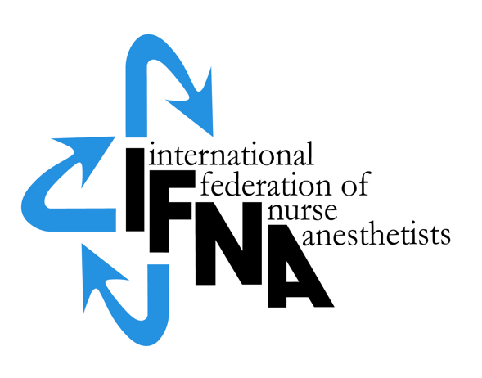

**APPLICATION**

**FOR NURSE ANESTHESIA PROGRAMS**

**IFNA ACCREDITATION**

**Deemed Accreditation Status Option**

Effective May 2016

Revised: September 2024

**All rights reserved**

**© IFNA**

**Introduction**

The International Federation of Nurse Anesthetists (IFNA) is a global organization representing the specialty of nurse anesthetists. The IFNA Bylaws (Article VII) definition of Nurse Anesthetist is:

“A Nurse Anesthetist is an Advanced Practice Nurse who has the knowledge, skills and

competencies to provide individualized care in anesthesia, pain management, and related

anesthesia services to patients across the lifespan, whose health status may range from healthy

through all levels of acuity, including immediate, severe, or life threatening illnesses or injury”.

The title “nurse anesthetist” may vary from country to country and the IFNA Council of National Representatives (CNR) recognizes that other titles such as: anesthesia nurse, nurse specialist in anesthesia, advanced practice nursing in anesthesia, etc may be used to define the specialty.

IFNA has developed a program approval process with three categories of approval. Programs are to apply for only one category. This application is to determine eligibility for **IFNA Accreditation** through a Deemed Accreditation Option. A program is required to demonstrate that its official governmental or non-governmental standards for nurse anesthesia education include an onsite evaluation and are equivalent to or exceed IFNA's Educational Standards; a self study and onsite visit are not required.

The steps in the accreditation process are attached.Following a successful accreditation process, the program’s identity, title of award, and curriculum will be posted on IFNA’s website with a statement that *"Anesthesia education programs holding IFNA Accreditation awarded through the Deemed Accreditation Option have: (1) met eligibility and application requirements for this category and (2) demonstrated that their official governmental or non-governmental nurse anesthesia education standards included an onsite evaluation and are equivalent to or exceed IFNA's Education Standards for Preparing Nurse Anesthetists. A nurse anesthesia program having successfully completed the process has all the privileges of a program holding IFNA Accreditation. Information about the curriculum is current at date of application."* Title of certificate awarded: IFNA Accreditation.

**APPLICATION FOR NURSE ANESTHESIA PROGRAM - IFNA ACCREDITATION**

**Deemed Accreditation Status Option**

**Official Name and Address of Applicant Nurse Anesthesia Program:**

## Information about the nurse anesthetist Program Director (contact person):

Name:

Title:

Street Address (or P.O. Box)”

City:

Code:

Country:

Telephone: (Country Code, City Code and number)

Work:

Cell:

E-mail address:

1. **Eligibility questions**
   1. The goal of IFNA’s approval process is to encourage programs to comply with *IFNA’s Educational Standards for Preparing Nurse Anesthetists* through an approval process that takes cultural differences into consideration. Please review the *IFNA Educational Standards for Preparing Nurse Anesthetists* and the *IFNA Anesthesia Program Approval Process (APAP) Operational Policies and Procedures* manual posted on IFNA’s website prior to submitting this application to determine if your program is eligible for accreditation and willing to meet the requirements.
   2. Does your nurse anesthesia program (the applicant program) meet requirements to be considered for accreditation?
      1. Does the anesthesia program require that students have completed a basic nursing education program of at least 36 months in length prior to admission?
         1. Yes____
         2. No___

If no, please explain.

* + 1. Does the anesthesia program require that students have obtained nursing experience of at least one (1) year, preferably in an acute care setting prior to admission?
       1. Yes____
       2. No___
    2. Is the program of study at least 18 to 24 months in length?
       1. Yes____
       2. No___
    3. Is the primary purpose of the program to educate graduates to meet the needs of the country or region in which it resides?
       1. Yes____
       2. No___
    4. Does your nurse anesthesia program pledge to meet IFNA’s Educational Standards and program approval policies?
       1. Yes____
       2. No___
    5. Has the program been denied registration, recognition or accreditation by a governmental or nongovernmental accreditation or quality assurance entity at any time?
       1. Yes____
       2. No___

If yes, please explain.

**II. Information needed to determine equivalency of standards:**

1. Who establishes the standards and educational requirements for your nurse anesthesia educational program? Provide an official name and contact information.
2. Nurse anesthesia programs applying for IFNA Accreditation are to submit the following required documentation in English:
   * 1. A copy of the official governmental or non-governmental education standards, under which the applicant program operates.
     2. A copy of correspondence from the official governmental or non-governmental agency that confirms its approval of the nurse anesthesia program based on meeting the required standards and the date the approval expires.
     3. Evidence that an on-site evaluation of the program has been conducted by the official governmental or non-governmental agency.
     4. Payment of a 1500 Swiss Francs application fee to the IFNA Executive Office at ifna.rod@wanadoo.fr. (Programs found ineligible will receive a refund of 750 Swiss Francs.)

**III. Signatures**

Signature & title of authority responsible for the nurse anesthesia program

(Officer in charge):

_____________________________________________________________________

Signature & title of nurse anesthesia Program Director:

**____________________________­­­­­­­­­­­­­­­­­­­­­­­___________________________________________**

The completed application form and required documents (in English) should be submitted by e-mail to the IFNA Executive Office at [p.rod@ifna.site](mailto:p.rod@ifna.site).

**Notification to Nurse Anesthesia Program:**

You will be notified if your program is, or is not, eligible to seek IFNA Accreditation through the Deemed Accreditation Option. Eligible programs will be notified of the Education Committee's and IFNA Officer's decisions on awarding IFNA Accreditation after they determine if the official education standards are at least equivalent to IFNA's Education Standards.