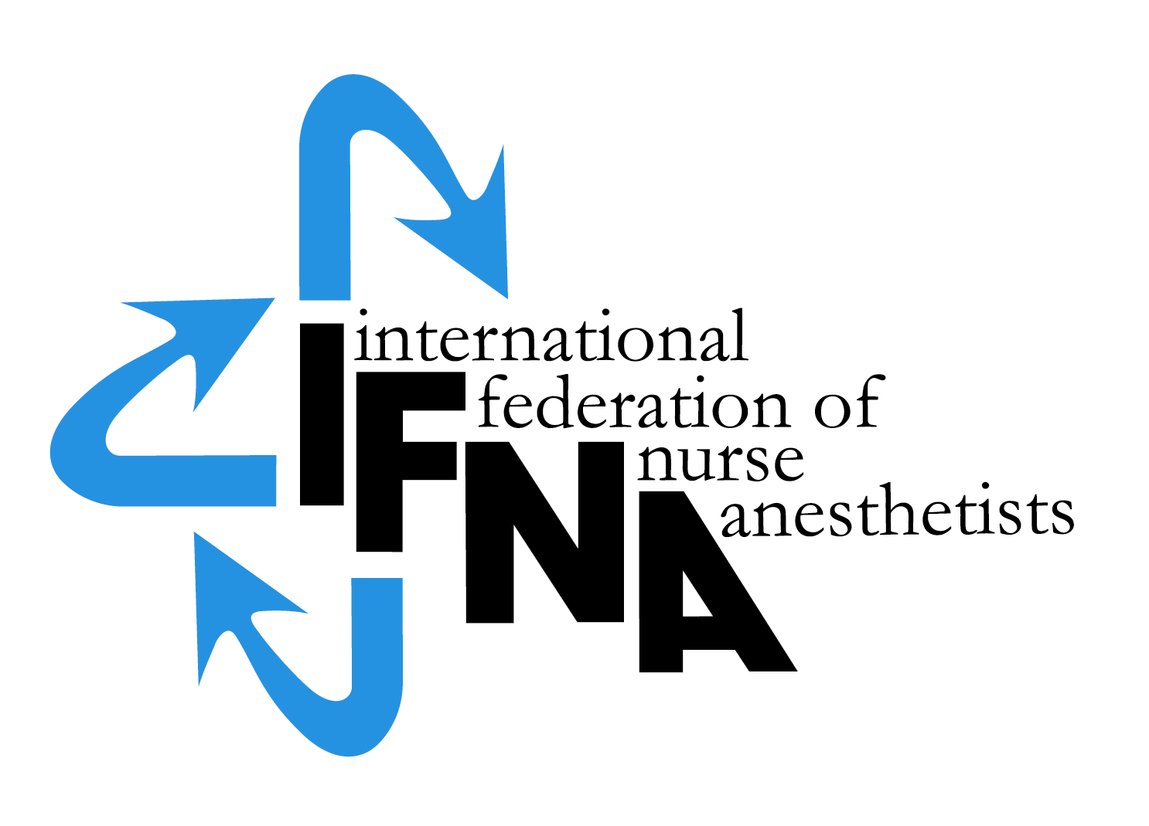

ELIGIBILITY APPLICATION

FOR NURSE ANESTHESIA

PROGRAM

Recognition

by the

International Federation of Nurse Anesthetists’ (IFNA)

Education Committee on Behalf of IFNA

Introduction:

The International Federation of Nurse Anesthetists (IFNA) is a global organization representing the specialty of nurse anesthetists. The IFNA Bylaws (Article VII) definition of Nurse Anesthetist is:

“A nurse anesthetist is a person who has completed a program of basic nursing education and a formal and/or actively pursuing a formal basic nurse anesthesia education and is qualified and authorized in his/her country to practice nurse anesthesia”.

The title “nurse anesthetist” may vary from country to country and the IFNA Council of National Representatives (CNR) recognizes that other titles such as: anesthesia nurse, nurse specialist in anesthesia, advanced practice nursing in anesthesia, etc may be used to define the specialty.

IFNA has developed a program approval process with three categories of approval. Programs are to apply for only one category. This application is to determine eligibility for IFNA Recognition, which includes a pledge for the program to meet the IFNA Educational Standards for Preparing Nurse Anesthetists to the best of its ability. The pledge includes the signature of the anesthesia program director and the highest institutional official. After the program is notified that it is eligible for recognition, the program will be asked to submit its curriculum and related material for review by the Education Committee. Following a successful recognition process, the program’s identity, title of award, and curriculum will be posted on IFNA’s website with a statement that IFNA has reviewed the curriculum, and related material and determined the program substantially meets the Educational Standards. Title of certificate awarded: IFNA Anesthesia Education Program Recognition.

Instructions:

Download a copy of the 2016 IFNA Educational Standards for Preparing Nurse Anesthetists and IFNA’s Anesthesia Program Approval Process (APAP) Operational Policies and Procedures that are posted on IFNA’s website at http://ifna.site/ifna-accreditation-program/approval-process-for-nurse-anesthesia-programs/. Review both documents thoroughly prior to the completion of this form.

Nurse anesthesia programs applying for recognition by IFNA are to complete this form. When submitting the form to the IFNA Executive Office, it should be accompanied by appropriate documentation to support what is said about the program in the application. For example, copies of course descriptions must be submitted in support of a written description of the curriculum. The application form requires the name of the Program Director who will be the contact for IFNA in the processing of the application.

- It is requested that the completed “IFNA Eligibility Application for Nurse Anesthesia Program Recognition” form be submitted by e-mail.

- A completed IFNA Eligibility Application form.

- Information about the program’s curriculum as follows:
  - Admission requirements
  - Course Titles / Curriculum
  - Course descriptions
  - Length of Program
  - Degree or certificate awarded to graduates

Please submit the completed application form and all of the items on this list by e-mail to the IFNA Executive Office at ifna.rod@wanadoo.fr.

Notification of Eligibility for IFNA Recognition:

You will be notified if your program is, or is not, eligible to seek IFNA Recognition. Eligible programs will be instructed to start the application process.

IFNA ELIGIBILITY APPLICATION FOR

NURSE ANESTHESIA PROGRAM RECOGNITION

Name and Address of Applicant Nurse Anesthesia Program

Information about the Nurse Anesthetist Program Director:

Name:
Title:
Street Address (or P.O. Box):
City:
Postal Code:
Country:

Home phone:
Work phone:
Fax: (please indicate if number is home or work)
E-mail address:

If there is no telephone or fax number, please list a name and number of an alternate contact (include Country Code, City Code and number)
Name:
Telephone:
Fax:

I. IFNA Educational Standards and Program Approval Policies

The goal of IFNA’s approval process is to encourage programs to comply with IFNA’s Educational Standards for Preparing Nurse Anesthetists through an approval process that takes cultural differences into consideration. Please review the IFNA Educational Standards for Preparing Nurse Anesthetists (2016) and the IFNA Anesthesia Program Approval Process (APAP) Operational Policies and Procedures manual posted on IFNA’s website prior to submitting this application to determine if your program is eligible for recognition and willing to meet the requirements.

- Does your nurse anesthesia program (the applicant program) meet requirements to be considered for recognition?

- Does the anesthesia program require that students have completed a basic nursing education program of at least 36 months in length prior to admission?
O Yes
O No

If no, what are the entry requirements?

- Does the anesthesia program require that students have obtained nursing experience of at least one (1) year, preferably in an acute care setting prior to admission?
O Yes
O No
- Does your nurse anesthesia program pledge to meet IFNA’s Educational Standards and program approval policies?
O Yes
O No

- Has the program been denied registration, recognition, or accreditation by a governmental or nongovernmental accreditation or quality assurance entity at any time?
O Yes
O No

II. General Information about education requirements for entry into Basic Nursing Education and Practice in your country, if applicable.

- Briefly describe the educational and other requirements for entry into basic nursing education in your country.

- What is the minimum age for entry into a basic nursing educational program?

- What are the number of months required to successfully complete the basic nursing education?

- Is licensure required to practice as a professional nurse?
O Yes
O No

If yes, is this by examination?
O Yes
O No

If no, how is the nurse recognized as a professional? (Please check (X) all that apply).
O The Ministry of Health
O The Ministry of Education
O Other, explain:

III. General information about Nurse Anesthesia Educational Programs and Requirements in your country.

- Are there other nurse anesthesia education programs in your country?
O Yes
O No

If yes, what is the number of schools?

- Are the programs (Check (X) all that apply).
O National
O Local
O Regional
O Private

- Are the programs (schools) approved?
O Yes
O No
O If yes, by whom are they approved?

- Is the nurse anesthesia educational program’s curriculum standardized throughout the country?
O Yes
O No

IV. Does your program admit non-nurses?
O Yes
O No

- Describe the entry requirements for non-nurses

- How long is the duration of your non-nurse anesthesia course?
# Months

- Are there other non–nurse anesthesia programs in your country
O Yes
O No

- Are the non-nurse anesthesia programs approved?
O Yes
O No
By whom are they approved?

- Is the non–nurse anesthesia curriculum standardized throughout your country?
O Yes
O No

- Are the programs (Check (X) all that apply):
O National
O Local
O Regional
O Private

- Do the graduates of your non–nurse anesthesia program substantially meet the Standards of Practice and Graduate Competencies
O Yes
O No

- Does the program teach the courses listed (Standard III) in the Educational Standards for preparing Nurse Anesthetists?
O Yes
O No

- Final credentials
O Certificate
O Diploma
O Degree

V. National Association

Is there a national nurse anesthesia organization in your country?

O Yes

O No

- Is there a national non-nurse anesthesia association in your country?
O Yes
O No

Official contact person for national association: (This individual should be a nurse anesthetist with whom the IFNA might contact).

Name:
Title:

Street Address (or P.O. Box):
Postal Code:

Country:
Telephone: (Country Code, City Code and number)
Home:
Work:
Fax: (please indicate if number is home or work)

E-mail address: (if available)

If there is no telephone or fax number, please list a name and number of an alternate contact (include Country Code, City Code and number)
Telephone: ______________________Fax:__________________________
VI. Information about your Nurse Anesthesia Program that is applying for IFNA Recognition (Applicant Program)

- Briefly describe the educational and other requirements for entry into your anesthesia educational program. This should include for example: years of nursing experience, type of nursing experience required, other type of pre-entry education, pre-entry evaluations, testing, dossier, etc. (Please list all of the requirements).

- What is the length of your anesthesia educational program?
# Months

- Describe who establishes the standards and educational requirements for your anesthesia educational program?

- Describe the content of your anesthesia educational program, including the amount of theory and clinical experience. Please include an example of the curriculum and a list of course titles (as an attachment).

- Describe the courses:

VII. Credentials
- What type of credential is offered upon successful completion of the applicant nurse anesthesia educational program?

O Certificate
O Diploma
O Degree
O Other

- Is this credential
O Local
O Regional
O National

- Is this credential recognized?
O Yes
O No
O If yes, by whom is it recognized?
- Is there a continuing education requirement following completion of the nurse anesthesia educational program?
O Yes
O No
O If yes, briefly explain:

VIII. General information about the scope of practice of your graduates in your country.
- Do graduates of your program prepare and check anesthesia machines, monitors, drugs, materials, and equipment for all anesthesia procedures?
O *independently
O *under indirect supervision
O *under direct supervision

- Do graduates of your program maintain the airway (do you insert masks, LMAs, endotracheal tubes)?
O Independently
O Under indirect supervision
O Under direct supervision

- Do graduates of your program administer and/or participate in the administration of general and regional anesthesia to all ages and categories of patients and surgical procedures?
O independently
O under indirect supervision
O under direct supervision

- Do graduates of your program emerge patients from anesthesia?
O independently
O under indirect supervision
O under direct supervision

- Are your graduates familiar with the management of a broad variety of anesthesia techniques, anesthetic agents, adjunctive and accessory drugs, as well as with pain management and safe sedation procedures?
O yes
O no

- Do your graduates understand and actively practice the effective analysis and utilization of invasive and noninvasive monitoring data?
O independently
O under indirect supervision
O under direct supervision

- Do your graduates recognize and take appropriate action when complications occur and immediately consult with appropriate others if patient safety requires it or if the incidence exceeds your scope of practice?
O independently
O under indirect supervision
O under direct supervision

- Do your graduates serve as resource persons in cardiopulmonary resuscitation, respiratory care, and other acute care needs?
O independently
O under indirect supervision
O under direct supervision

*Independently: you are allowed to work without supervision of an anesthesiologist

*Indirect supervision: the anesthesiologist is responsible for more than one theatre and may delegate the anesthesia or part of the anesthesia to you. He /she is available by phone or intercom if necessary.

*Direct supervision: the physician anesthesiologist is present during all phases of anesthesia (induction, administration and emergence of anesthesia). Your role is one of an assistant.

Signature & title of authority responsible for the nurse anesthesia program
(Officer in charge):

______________________________________________________________

Signature & title of nurse anesthesia Program Director:

___________________________________________________________________

Approved: June 2009
Effective: June 1, 2009
Revised: Nov. 2018
Approved: Nov. 2018
Revised: June 2019
Revised: Nov. 2023

