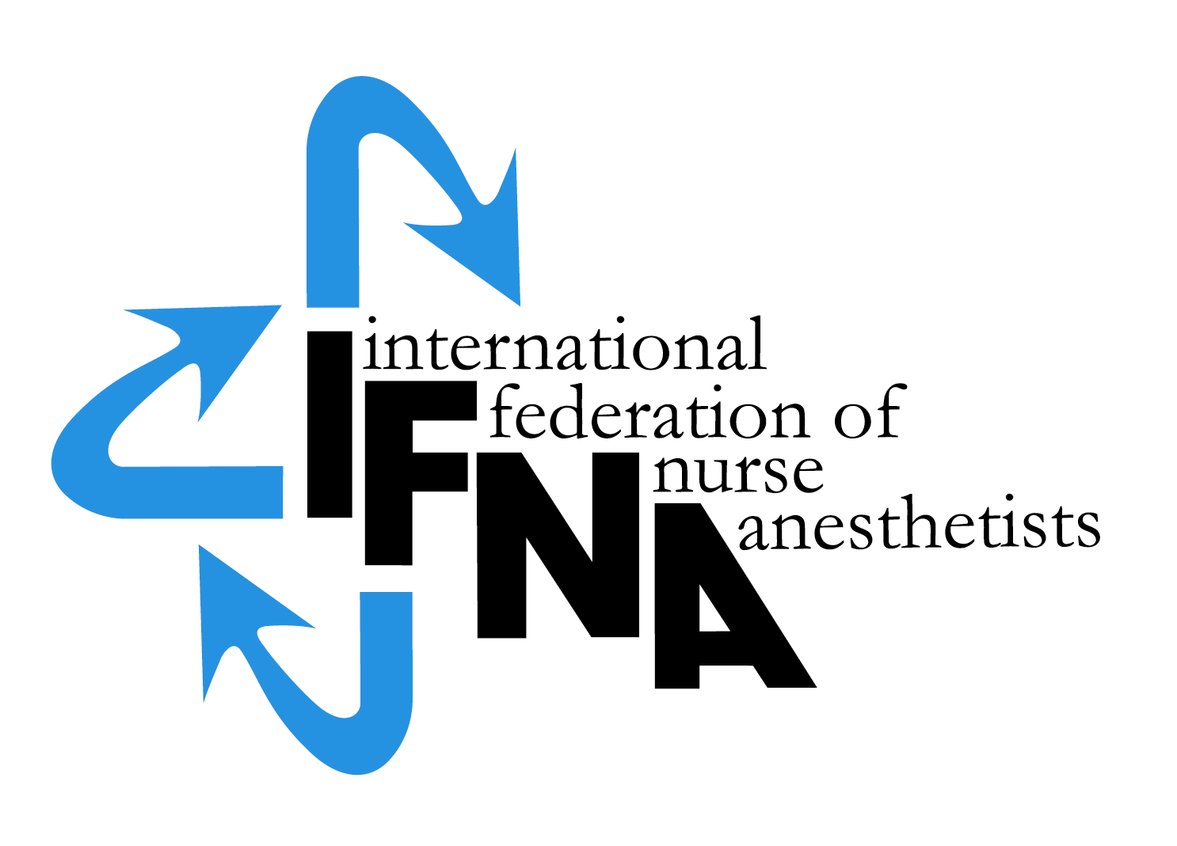

RENEWAL APPLICATION FOR NURSE & NON-PHYSICIAN

ANESTHESIA PROGRAM

LEVEL #2 - IFNA RECOGNITION

Effective 2015
Revised July 2016
Revised February 2017

All rights reserved
© IFNA

Renewal of Level 2 IFNA Recognition

The International Federation of Nurse Anesthetists (IFNA) is a global organization representing the specialty of nurse anesthetists. IFNA operates an Anesthesia Program Approval Process (APAP). IFNA's approval process takes cultural, national or regional differences into consideration. It is based on IFNA's belief that it is possible to improve the health and welfare of humanity by promoting international anesthesia educational standards.

Anesthesia programs holding Level #2 IFNA Recognition are to update their applications every 5 years as part of a renewal process.

For the renewal of IFNA recognition the program is required to submit its current curriculum for review by the IFNA Education Committee. The curriculum will be audited to determine if it substantially complies with the curriculum - standards in the IFNA Educational Standards for Preparing Nurse Anesthetists 2012 which can be downloaded from http://ifna.site. You can also request the documents from the APAP manager at: marianne.riesen@bluewin.ch. Faculty and student evaluations will also be conducted as part of the audit.

Following the successful completion of the renewal of recognition process, the program’s identity, title of award and the current curriculum will be posted on IFNA’s website with a statement that IFNA has audited the curriculum and determined it substantially meets its requirements. Title of award: IFNA Recognition.

Notice:
Programs are requested to download and review all of the new Education Standards (2016) while noting that Standard IV, Graduate Competencies, will be included in curriculum audits beginning in May 2019. This advance notice should allow programs time to revise their curricula, if needed, so graduates will have the knowledge and skills required in Standard IV. http://ifna.site/. For this reason, the current recognition process is still based on the graduate competencies (2012) which you will find under chapter V of this document.

Instructions

- A copy of IFNA’s Educational Standards for Preparing Nurse Anesthetists and IFNA’s Anesthesia Program Approval Process (APAP) Operational Policies and Procedures are available on IFNA’s website. The Educational Standards and policies and procedures (2012) should be reviewed prior to the completion of this form.

- Anesthesia programs applying for renewal of Level #2 IFNA Recognition are to complete this form. When submitting the form to the IFNA Executive Office, it should be accompanied by appropriate documentation to support what is said about the program in the renewal application. The application form requires the name of the Program Director [*] who will be the contact for IFNA in the processing of the application. ([*] indicates a Glossary term.)

- The application and supporting documentation must be in English. Submitted documents must include at a minimum:

A completed application - Renewal Application for Nurse and Non-physician Anesthesia Program - Level #2 Recognition.
- Evidence in the form of a letter, certificate, etc. to show authorization from a governmental or private entity that the program has official status (if available in the country).
- CV or resume of the program director or program leader.
- A list of course titles and course descriptions.
- A brief overview of the curriculum (to be posted at the end of a successful renewal process - example attached to the application).

- The completed “IFNA Renewal Application" should be submitted by e-mail to the IFNA APAP Manager at marianne.riesen@bluewin.ch

Note to Programs on Decisions for Renewal

The Education Committee will obtain final decisions on renewal applications from the IFNA Board of Officers and Country National Representatives (CNR) at their next meeting after the program’s application for renewal has been evaluated by the members of the education committee. Program directors will be notified in writing of decisions.

Official Name of Anesthesia Program:

Information about the Program Director:
Name:
Title:
Mailing Address:
Country:
Telephone: (Country Code, City Code and number)
Home:
Cell:
Work:
Fax:
E-mail address:

- IFNA Educational Standards and Program Approval Policies

The goal of IFNA’s approval process is to encourage programs to comply with IFNA’s Educational Standards for Preparing Nurse Anesthetists. Please review the downloaded IFNA Educational Standards for Preparing Nurse Anesthetists (2012) to determine if your program continues to be willing to meet the requirements.

  - Faculty and students in APAP approved programs should be familiar with IFNA's Education Standards.
    - Have faculty reviewed the Education Standards?
      - Yes O
      - No O

    - Have students reviewed the Education Standards?
      - Yes O
      - No O

  - Your anesthesia program must continue to meet eligibility requirements for Level #2 IFNA Recognition.

    - Does the anesthesia program only educate non-physicians?
      - Yes O
      - No O

    - How many nurses and other types of students are enrolled in your program?
      - Nurses (#) _____
      - Others (#) _____

    - Does the anesthesia program have admission requirements that include an education in nursing or another scientific background that prepares a student to succeed in the anesthesia program?
      - Yes O
      - No O

    - Is the primary purpose of the program to educate graduates to meet the needs of the country or region in which it resides?
      - Yes O
      - No O

    - Does your anesthesia program pledge to meet IFNA’s Educational Standards and program approval policies to the best of its ability?
      - Yes O
      - No O

    - Is the program authorized, recognized, chartered, audited, accredited or have some equivalent official status in your country?
      - Yes O
      - No O
      - Not available in our country ___

    - Has the program been denied registration, recognition or accreditation by a governmental or nongovernmental accreditation or quality assurance entity at any time?
      - Yes O
      - No O

- Information about your anesthesia program that is applying for renewal of IFNA Recognition

  - Briefly describe the educational and other requirements for entry into your non-physician anesthesia educational program. This should include: years of nursing or other experience, type of nursing or other experience required, pre-entry evaluations, testing, dossier, etc. (Please list all of the requirements.)

  - What is the length of your anesthesia educational program?
    - ______years
    - ______months

  - Who establishes the standards and educational requirements for your anesthesia educational program?

d. Describe the type of official evidence from a governmental entity that the program is currently authorized, recognized, chartered, audited, accredited or has some equivalent official status in the country - if available. (Add evidence in the form of a letter, certificate, etc. to this application).

e. Describe the content of your anesthesia educational program, including the amount of theory and clinical experience. Please include an example of the curriculum including a list of course titles.

f. Please explain any differences between the curriculum for nurse and non-nurse students.
g. Please describe any major changes that have occurred in your anesthesia program since it first received Level #2 IFNA Recognition. Include supporting documentation as indicated. (Examples of major changes: a change in program director, organizational structure, funding, changes in curriculum, changes in certificate or degree awarded, or the status of approval by external agencies.)
h. URL for program’s website (if available)

- Credentials
  - What type of credential is currently offered upon successful completion of the anesthesia educational program?
    - Certificate O
    - Diploma O
    - Degree O
    - Other O

  - Is this credential
    - Local O
    - Regional O
    - National O

  - Is this credential recognized
    - Yes O
    - No O
    - If yes, by whom is it recognized?

  - Is there a continuing education requirement following completion of the non-physician anesthesia educational program?
    - Yes O
    - No O
    - If yes, briefly explain:

IV. Do you have the following courses related to the practice of anesthesia?

Directions: Check the appropriate box, yes or no. [*] indicates a glossary term.

Advanced Anatomy, Physiology and Pathophysiology.
O Yes O No

Advanced Pharmacology to include anesthesia agents, adjunctive and accessory drugs [*].
O Yes O No

Chemistry and Physics of Anesthesia.
O Yes O No

Principles of Nurse Anesthesia Practice.
O Yes O No

Anesthesia and monitoring techniques.
O Yes O No

Anesthesia and related equipment
O Yes O No

Patient assessment [*]
O Yes O No

Anesthesia for different ages and categories of patients and for the full variety of surgical and medically related procedures wherein anesthesia is required.
O Yes O No

Resuscitation and other life sustaining procedures, such as intubation, ventilation, arterial and intravenous punctures, fluid and blood therapy, etc.
O Yes O No

Pain management
O Yes O No

Infection control and patient safety
O Yes O No

Record keeping / documentation
O Yes O No

Organization and planning
O Yes O No

Professional Aspects of Nurse Anesthesia Practice.
O Yes O No

Quality assurance [*] and improvement
O Yes O No

Legal aspects of practice, ethical considerations in practice
O Yes O No

Interpersonal relationships, rights, responsibilities of health providers, patients, their families and significant others
O Yes O No

Principles of Research and Evidence Based Practice [*] are strongly recommended. Is this included in your curriculum?
O Yes O No

Self-learning skills and methods to maintain competence throughout the professional career.
O Yes O No

Collaboration and communication skills
O Yes O No

Clinical Practicum Requirements

The clinical practicum requirements shall be designed to provide the graduate clinical experience inherent in the list of required competencies for nurse anesthetists for which he/she is being prepared. Are there sufficient numbers and varieties of clinical experiences for all of your students?
O Yes O No

It is recommended and strongly encouraged that at least 50% of the program be devoted to clinical learning experiences. Is clinical experience 50% of your program?
O Yes O No

V. Does your anesthesia program prepare graduates to achieve the following competencies?
Graduate competencies 2012
Nurse anesthetists as experts
Perform and/or participate in the performance of a preanesthetic interview and physiological and psychological assessment (*)
O Yes O No

Evaluate and/or collect patient information from the patient's history, physical examination, laboratory, radiographic and other diagnostic data and identify relevant problems
O Yes O No

Prepare and/or implement (*) an appropriate anesthesia care plan
O Yes O No

Administer and/or participate in the administration of general and regional anesthesia to all ages and categories of patients for a variety of surgical and medically related procedures
O Yes O No

Use a broad variety of techniques, anesthesia agents (*), adjunctive and accessory drugs (*), and equipment in providing anesthesia care and pain management
O Yes O No

Interpret and utilize data obtained from the effective use of current invasive and non- invasive monitoring modalities
O Yes O No

Initiate and manage fluid and blood therapy within the plan of care
O Yes O No

Recognize and take appropriate actions with reference to complications occurring during anesthesia management
O Yes O No

Position or supervise positioning of patients to assure optimal physiologic function and patient safety
O Yes O No

Identify and take appropriate action related to anesthesia equipment problems
O Yes O No

Identify patient problems and take appropriate action in the immediate postoperative period
O Yes O No

Assess (*) patient responses for readiness to move to next level of care
O Yes O No

Serve as a resource person (*) in cardiopulmonary resuscitation, respiratory care, and for other acute care needs
O Yes O No

Utilize appropriate principles of basic and behavioral sciences in protecting patients from iatrogenic complications
O Yes O No

Document assessment and monitoring data and nursing and anesthesia care provided
O Yes O No

Nurse anesthetists as communicators
Provide a calm environment for patients
O Yes O No

Establish a rapport with patients
O Yes O No

Listen effectively and integrate information from more than one participant where necessary
O Yes O No

Communicate verbally and non – verbally
O Yes O No

Ensure patient confidentiality and discretion
O Yes O No

Assure patient understanding, respect, empathy and trust
O Yes O No

Engage in effective interpersonal and intraprofessional communication
O Yes O No

Communicate understandably, discuss information appropriately with parents, relatives and team members (e.g. negative prognoses, ethical dilemmas etc.)
O Yes O No

Nurse anesthetists as collaborators
Respect roles and competencies of other team members
O Yes O No

Decide together with team members in the interest of the patients
O Yes O No

Constructively discuss team strengths and weaknesses
O Yes O No

Listen to questions and concerns of others
O Yes O No

Give feedback and accept feedback from other team members
O Yes O No

Ensure consistent information flow to patients and colleagues.
O Yes O No

Seek consultation as appropriate
O Yes O No

Recognize personal and professional attributes; demonstrate ability to interact with personnel on a professional level
O Yes O No

Function within appropriate legal requirements as a professional nurse, accepting responsibility and accountability for his/her own practice
O Yes O No

Nurse anesthetists as scholars
Develop and implement a strategy for life - long learning
O Yes O No

Search available data e.g. internet, databases and literature
O Yes O No

Evaluate literature critically
O Yes O No

Practice evidence - based (*) health care
O Yes O No

Spread knowledge to promote the health and well- being of human beings and to develop the profession
O Yes O No

Nurse anesthetists as managers
Use existing resources effectively and economically
O Yes O No

Be concerned about ecological issues
O Yes O No

Utilize appropriate decision-making skills
O Yes O No

Anticipate situations and prepare in advance for challenges (discuss procedures and possible complications in advance)
O Yes O No

Maintain appropriate time management
O Yes O No

Nurse anesthetists as professionals
Accept responsibilities and correctly delegate responsibilities to other team members
O Yes O No

Be reliable and give and take feedback with colleagues and other health care professionals
O Yes O No

Know and accept the limitations of self and of others
O Yes O No

Accept responsibility for own errors
O Yes O No

Apply practices of quality assurance and improvement
O Yes O No

Provide accurate documentation
O Yes O No

Contribute to an agreeable working environment
O Yes O No

Assess and correct own actions using reflective practice
O Yes O No

Apply error management
O Yes O No

Report critical incidents to the central critical incidents reporting system (CIRS)
O Yes O No

Critique constructively and accept criticism
O Yes O No

Act according to ethical principles
O Yes O No

Know and adhere to medicolegal constraints
O Yes O No

Recognize personal and professional attributes
O Yes O No

Act considering cultural, gender, race, religious and other possible difference
O Yes O No

Practice adequate stress – and self- management
O Yes O No

Nurse anesthetists as health care advocates
Promote individual health care
O Yes O No

Consider various influences on patients’ health status (e.g., biological, psychological, social, environmental and cultural influences)
O Yes O No

Detect health related and anesthetic risk factors; address behavioural change: e.g., instruction of smoking cessation during pre - anaesthetic assessment
O Yes O No

Participate in the education of patients and other members of the community of interest (*)
O Yes O No

V. Please describe any significant changes in the program that have occurred during the previous 5 years. Include progress that has been made toward meeting all of IFNAs Education Standards. Also report any action you have taken on earlier recommendations that were included in your official letter of recognition received from IFNA 5 years ago, if any.

VI. Information for IFNA's Website
According to APAP policy, the program identity, title of award and curriculum are posted on IFNA's website. Please provide a brief overview of the curriculum to be posted at the end of a successful renewal process. An example is attached (Appendix A). For publication on the IFNA website you can use the curriculum format at the end of this document (Appendix B) to enter your courses and credits.

We are applying for renewal of Level #2 IFNA Recognition

We are submitting an application for renewal of Level #2 IFNA Recognition. We understand that the curriculum will be posted on IFNA’s website if the program is renewed. We pledge to meet the IFNA Educational Standards for Preparing Nurse Anesthetists to the best of our ability.

Signature & title of authority responsible for the anesthesia program (Officer in charge):

Signature & title of anesthesia Program Director:

__________________________________________________________________________________

Appendix A: EXAMPLE of Website PUBLICATION

Official name of nurse anesthesia program
Name of program director:
Title:
Mailing address
Country
CURRICULUM OVERVIEW

Degree Awarded: Master of Science in Nursing with a Specialization in Nurse Anesthesia

Term and Course Credits
Fall (16)
NURS 5010 Graduate Anatomy 5
NURS 5001 Graduate Physiology 4
NURS 5700 Basic Principles of Anesthesia w/Equipment & Technology #1 1
NURS 5710 Chemistry & Physics Applied to Anesthesia 3
NURS 5711 Pharmacology related to Anesthesia 3

Spring (15)
NURS 5101 Advanced Pathophysiology 3
NURS 5109 Advanced Pharmacology 3
NURS 5701 Basic Principles of Anesthesia #2 3
NURS 5715 Advanced Health Assessment for Nurse Anesthesia 3
NURS 5240 Statistics & Epidemiology for Advanced Practice 3

Summer (12)
NURS 5250 EBP & Research Methods 3
NURS 5215 Health Promotion in Individuals & Vulnerable Populations 3
NURS 5702 Advanced Principles of Anesthesia #1 3
NURS 5730 Clinical Experience I (OR on W/Th/F) 3

Fall (12)
NURS 5910 Research & Theory Integration 3
NURS 5223 Health Care Policy & Ethics 3
NURS 5703 Advanced Principles of Anesthesia #2 3
NURS 5731 Clinical Experience II (OR on W/Th/F) 3

Spring (10)
NURS 5228 Organization & Systems Leadership 3
NURS 5720 Professional Aspects of Nurse Anesthesia 3
NURS 5732 Clinical Experience III (OR on T/W/Th/F) 4

Summer (6.5)
NURS 5740 Clinical Correlation Conferences 1.5
NURS 5733 Clinical Experience IV (OR on M/T/W/Th/F) 5

Fall (6.5)
NURS 5741 Clinical Correlation Conferences 1.5
NURS 5734 Clinical Experience V (OR on M/T/W/Th/F) 5

Total Hours 78

Appendix B: Form for curriculum to be posted on IFNA's website

Official Name of the Nurse Anesthesia Program:
Name of program director:
Title:
Mailing address
Country

Curriculum Overview
Degree/ Diploma / Certificate awarded:

Term / Course title hours / credits
Semester

Glossary
Anesthesia, Adjunctive and Accessory Drugs: Three categories of drugs which are utilized in anesthesia practice and included as required content within the advanced pharmacology courses provided as a part of the nurse anesthetist educational program.
- Anesthesia Drugs. Those drugs having an anesthesia or analgesic, hypnotic, sedative effect which are used for that purpose in the administration of an anesthetic.
- Adjunctive Drugs. Those drugs needed to provide other anesthesia and/or surgical conditions as a part of the anesthetic. These include such drugs as muscle relaxants used for intubation or skeletal muscle relaxation or hypotensive agents in the event that intentional hypotension is utilized to minimize bleeding.
- Accessory Drugs. Those drugs which patients require and take as a part of their current physical or psychological condition which may have an effect upon the choice of anesthesia and/or adjunctive drugs. Also, those drugs which patients may require during an anesthetic to maintain physiologic balance within normal limits, or to correct a complication.

Assessment: The initial component of the nursing process. (Assessment, Problem Identification, Planning nursing care, Implementing the nursing care, and Evaluating nursing care); The nursing equivalent to medical examination: reviewing a patient's health history and current health problems and physical status as a basis for determination of the care needed that the nurse will provide or within which she / he will participate. For the nurse anesthetist, patient assessment is a required function before, during, and after the provision of an anesthetic.

Care Plan: Documentation of nurse anesthesia process inclusive of assessment, planning, implementation and evaluation.

Community of Interests: Those groups of people who have significant interest in a particular endeavor. In the case of anesthesia, the community of interests may be the patient, family, surgeon, anesthesia providers (physician and nurse), other nurses who will care for the patient before, during, and after the anesthesia and surgery, and hospital administration.
In the case of nurse anesthetist education, the community of interests will be the profession, students, faculty, employers, and the public as potential patients who would be beneficiaries of the services provided by the graduates of these programs.
In the case of clinical practice this community of interest may even extend to pharmaceutical companies and medical equipment manufacturers depending upon the particular circumstances. In the case of nurse anesthetist education, the community of interests will be the profession, students, faculty, employers, and the public as potential patients who would be beneficiaries of the services provided by the graduates of these programs.

Evidence Based Practice: Integration of clinical expertise, patient values and the best research evidence into the decision making process for patient care.

Hazards: A situation of risk or potential harm to the health care worker or patient which includes but is not limited to pollution, lasers or x-ray exposure.

Perioperative: Around the operative period: preoperative, intraoperative, and postoperative.

Program Director/Leader: It is a Nurse Anesthetist responsible for directing a program including involvement in student selection, curriculum development, student and faculty evaluations.

Quality: An attribute or characteristic of a product or service, denoting a grade of excellence. When applied to anesthesia practice, it depicts the provision of an anesthesia service(s) which can be categorized as beyond that level of assuring safety and being compliant with standards for practice, but rather exceeds those standards, and sets the stage, barring unforeseeable events, for achieving the best potential outcome from the care provided.

Resource Person: An individual, who by education and experience has acquired a level of expertise in a field of endeavor, and is capable of assisting, advising, consulting with, or supervising other personnel in the provision of a service falling within the area of their expertise.
Example: The nurse anesthetist, as an expert in airway management and ventilation, may serve as a resource person to other health providers in correcting an airway or ventilation problem of a patient, or because of her /his expertise in resuscitation techniques may serve as a leader or member of a resuscitation team in the event of cardiopulmonary failure or severe trauma. The nurse anesthetist may also serve as a teacher to assist others to learn the techniques for correcting airway problems or resuscitating patients in cardiopulmonary failure and in so doing is a resource person for teaching.

Curriculum overview courtesy of B. Henrichs, Goldfarb School of Nursing at Barnes-Jewish College, Nurse Anesthesia Program, St. Louis, Missouri, USA

