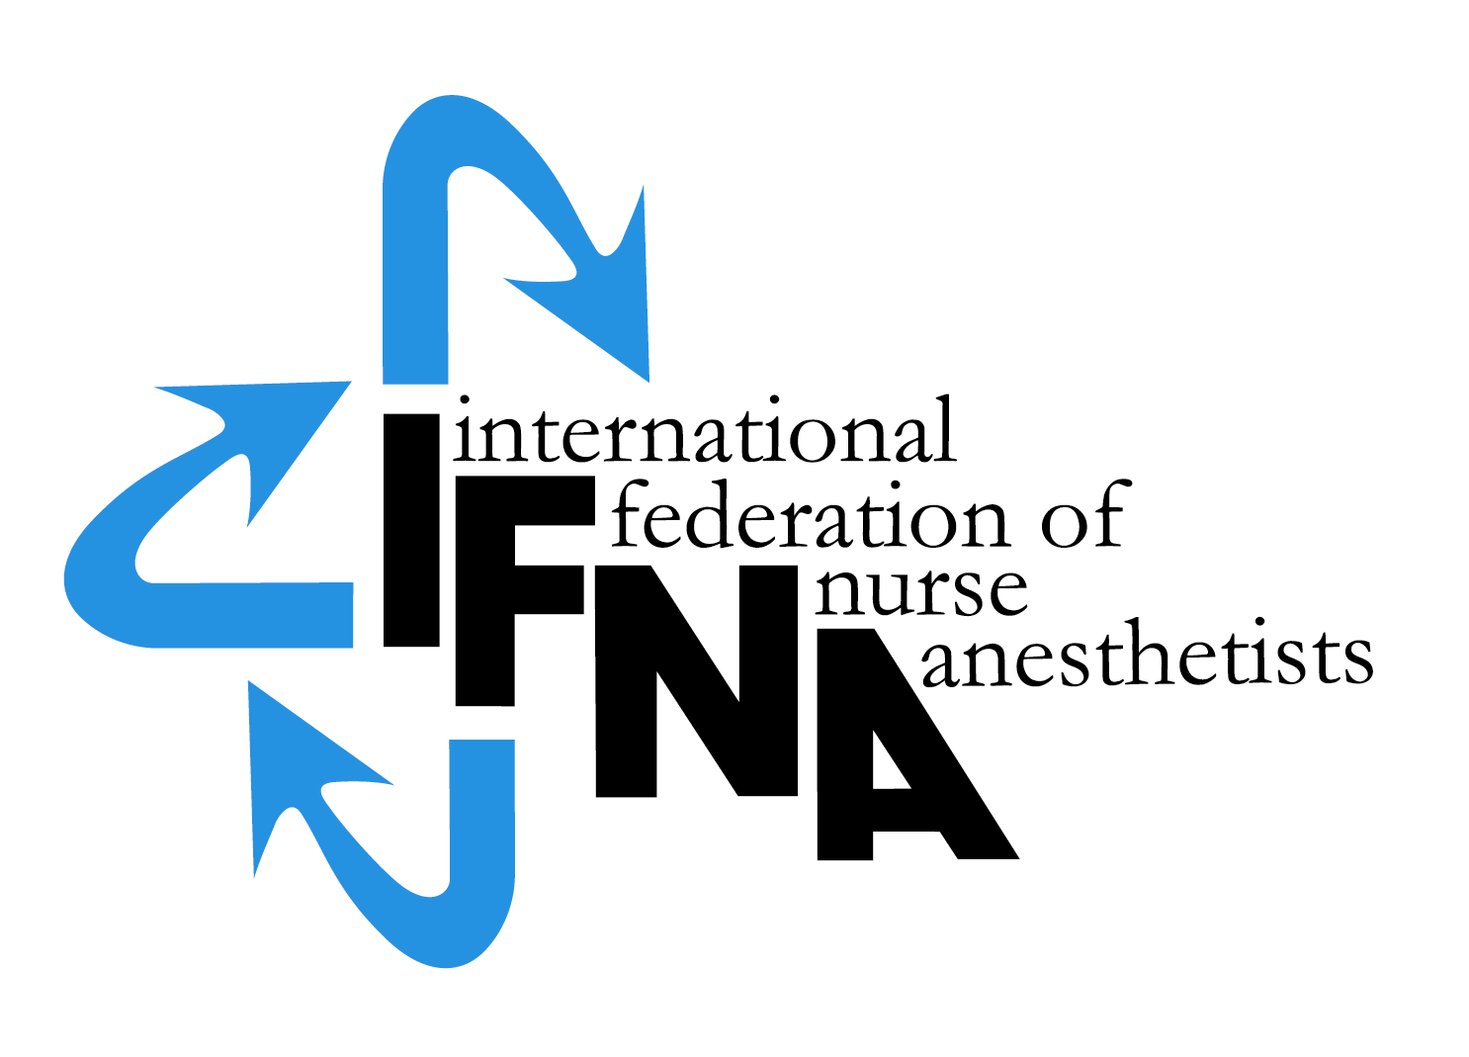

IFNA Grant for Student, Faculty and Nurse Anesthesia Practitioner Exchange Guidelines

Background:

International collaboration between health care institutions is becoming more and more important and many educational institutions see it as a part of their mission to promote international collaboration in order to improve global health care. The International Federation of Nurse Anesthetists (IFNA) also sees it as its Mission to advance the art and science of anesthesiology and enhance quality of anesthesia worldwide. In the IFNA Mission – Statement it is said:

“The IFNA strives to establish and maintains effective cooperation with institutions that have a professional interest in nurse anesthesia” (International Federation of Nurse Anesthetists, 2012, Standards & Code of Ethics, IFNA Mission-Statement)
The IFNA Objectives, among other things, underlines that it is important to promote cooperation between nurse anesthetists and anesthetists internationally, to develop and promote educational standards in the field of nurse anesthesia and finally to develop and promote standards of practice in the field of nurse anesthesia.
Therefore at the World congress in Slovenia 2012, IFNA decided to develop Guidelines for student, faculty and nurse anesthesia practitioner (including non-physician anesthesia practitioner) exchange worldwide.

Programs eligible to receive Grants should all be located in IFNA member countries. At least one of the programs should be approved by APAP (Approval Process for Anesthesia Programs) level #2 or level #3. An exchange should be of benefit for both parts in the exchange. Examples: Student, faculty and nurse anesthesia practitioners participate in the exchange as equally as possible. Only future exchange projects are eligible for Grants.

Aims
The following aims should serve as guidelines for the exchange:

To promote and intensify collaboration between educational partner institutions worldwide
To get an understanding of the nurse anesthesia programs worldwide
To promote collaboration and increase understanding of the cultural differences between the partners in the exchange activities
To get an understanding of the host country’s conditions for anesthesia health care
To learn about alternate health systems and how to solve health care challenges in the host country
To identify and gain a wider perspective upon the profession in the host country

Objectives
The following objectives should serve as guidelines for the exchange:

To identify current anesthetic methods and medications in the host country
To identify the competencies and the daily practice of nurse anesthetists in the host country
To identify the structure and organization of the anesthesia ward and to describe the management of the patients pre-, per- and postoperatively
To formulate an anesthetic care plan and under supervision provide anesthesia care if possible to common surgical patients
To develop an understanding of the nurse anesthesia education in the host country as well as the country of the visiting student and/or faculty and anesthesia practitioner
To communicate the findings at sessions in their home institutions, nationally and internationally

Instructions for Grant Application for Student, faculty and nurse anesthesia practitioner exchange:

An application form should be performed preferably by the director responsible for a Nurse Anesthesia Program. The application form requires the name of the Program Director who will be the contact for IFNA in the processing of the application and should also include the names of the other programs involved in the exchange. It is requested that the completed “IFNA Grant Application for Student, faculty and nurse anesthesia practitioner exchange” form in English be submitted by e-mail to the IFNA Executive Office at ifna.rod@wanadoo.fr. It should be accompanied by appropriate documentation, for example a written description of the curriculum and specification to the budget in form of prices for flights and accommodation.
Application deadline: March 01 and September 01.
The following items are to be submitted:

- General Information about the program’s curriculum:
  - Name of the Anesthesia Programs involved
  - Course Titles
  - Length of Programs
  - Name of the Program Directors

- Proposed Exchange Activities
a. A statement that addresses how the different programs will benefit from exchange activities.
b. A specification of activities describing how the exchange program both include students, faculty and practitioners.
c. A statement that guarantees that the student should be guaranteed that the objectives of her/his own anesthesia program during the exchange period will be achieved in addition to the objectives of the exchange activities.

- Budget, Timetable and Specifications
  - Specification of direct costs of exchange (web-copies of different flight-prices and prices for accommodation as attachment)
  - A statement that states why the program is not able to pay costs associated with exchange activities.
  - Timetable including period and duration of the stay

4. Evaluation

a. Evaluation of the exchange program.

b. Public dissemination (presentation or poster at WCNA)

Notification of Eligibility for IFNA Exchange:
You will be notified if your program is, or is not, selected to participate in the IFNA Exchange Grant. The selected program will be published on IFNA´s website.

Thank you!

