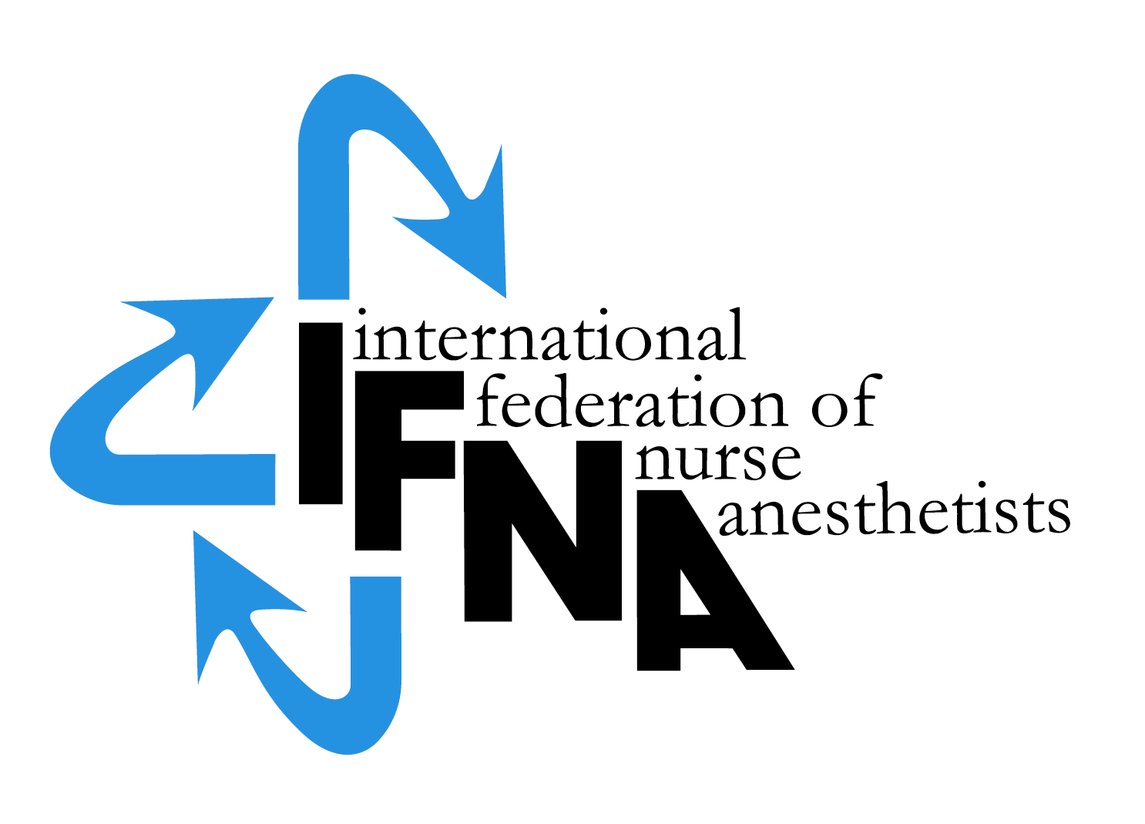

IFNA Accreditation Grant Application 2015

FOR NURSE ANESTHESIA
PROGRAM ACCREDITATION

by the

International Federation of Nurse Anesthetists’ (IFNA)
Education Committee on Behalf of IFNA

Introduction:

The International Federation of Nurse Anesthetists (IFNA) is a global
organization representing the specialty of nurse anesthetists. The IFNA Bylaws
(Article VII) definition of Nurse Anesthetist is:

“A nurse anesthetist is a person who has completed a program of basic
nursing education and a formal and/or actively pursuing a formal basic
nurse anesthesia education and is qualified and authorized in his/her
country to practice nurse anesthesia”.

The title “nurse anesthetist” may vary from country to country and the IFNA
Council of National Representatives (CNR) recognizes that other titles such as:
anesthesia nurse, nurse specialist in anesthesia, advanced practice nursing in
anesthesia, etc. may be used to define the specialty.

IFNA has developed a program approval process with three categories of
approval. Programs are to apply for only one category. This application is for
Level #3, IFNA Accreditation, which includes a pledge for the program to meet
the IFNA Educational Standards for Preparing Nurse Anesthetists to the best of
its ability. The program selected for the grant will be asked to submit its
curriculum and related material in a written self study for review by the Education
Committee. The information will also evaluated by a team of onsite visitors to
determine if it meets the Educational Standards.

Following a successful accreditation process, the program’s identity, title of
award, and curriculum will be posted on IFNA’s website with a statement that
IFNA has reviewed the curriculum, reviewed a self study, conducted an on-site
visit to the program and determined the program substantially meets all of the
Educational Standards. The website will note that the program has substantially
met the Educational Standards as determined by a full review of the program
including a written self study and on-site review.

Title of certificate awarded: IFNA Anesthesia Education Program Accreditation.

Instructions:

A copy of IFNA’s Educational Standards for Preparing Nurse Anesthetists and
IFNA’s Anesthesia Program Approval Process (APAP) Operational Policies and
Procedures are posted on IFNA’s website at www.ifna-int.org. It is strongly
recommended that the Educational Standards and policies and procedures be
reviewed prior to the completion of this form.

Nurse anesthesia programs applying for accreditation by IFNA are to complete
this form. When submitting the form to the IFNA Executive Office, it should be
accompanied by appropriate documentation to support what is said about the
program in the application. For example, copies of course descriptions should be
submitted in support of a written description of the curriculum. The application
form requires the name of the Program Director who will be the contact for IFNA
in the processing of the application.

It is requested that the completed “IFNA Accreditation Grant Application”
form be submitted by e-mail to the IFNA Executive Office at
ifna.rod@wanadoo.fr. The following items are to be submitted:

- A completed IFNA Accreditation Grant Application form
- Information about the program’s curriculum as follows:
  - Admission requirements limited to nurses
  - The year the program began and the number of graduating classes
- where students have graduated from essentially the same
- curriculum
  - Course Titles
  - Length of Program
  - Degree or certificate awarded to graduates
  - A statement that addresses how accreditation will benefit the program.
  - A pledge by the program that it will cooperate with the IFNA Education
Committee in meeting timelines is required.

Please submit all of the items on this list in English by e-mail to the IFNA
Executive Office at ifna.rod@wanadoo.fr.

Notification of Eligibility for IFNA Accreditation:

You will be notified if your program is, or is not, selected to participate in the
IFNA Accreditation Grant project. The selected program will be instructed to start
the self-study process in preparation for an on-site visit.

Thank you!

IFNA ACCREDITATION GRANT APPLICATION

Official Name of Applicant Nurse Anesthesia Program

____________________________

Information about the nurse anesthetist Program Director:

Name:
________________________________________________

Title______________________________________________

Street Address (or P.O. Box)

_______________________________

_________________________________________________

_________________________________________________

Code: ______________City________________________________

Country___________________________________________

Telephone: (Country Code, City Code and number)

Home: _____________________________

Work: ______________________________

Fax: (please indicate if number is home or work)

___________________________________

E-mail address: _______________________

If there is no telephone or fax number, please list a name and
number of an alternate contact (include Country Code, City
Code and number)

Telephone: _______________________

Fax:___________________________

IFNA Educational Standards and Program Approval Policies

(1) The goal of IFNA’s approval process is to encourage programs to
comply with IFNA’s Educational Standards for Preparing Nurse
Anesthetists through an approval process that takes cultural
differences into consideration. Please review the IFNA Educational
Standards for Preparing Nurse Anesthetists and the IFNA
Anesthesia Program Approval Process (APAP) Operational Policies
and Procedures manual posted on IFNA’s website prior to
submitting this application to determine if your program is eligible
for accreditation and willing to meet the requirements.

(2) Does your nurse anesthesia program (the applicant program) meet
requirements to be considered for accreditation?
- Yes____
- No___

(3) Does the anesthesia program require that students have
completed a basic nursing education program of at least 36
months in length prior to admission?
- Yes____
- No___

(4). Does the anesthesia program require that students have
obtained nursing experience of at least one (1) year,
preferably in an acute care setting prior to admission?
- Yes____
- No___

(5). Does your nurse anesthesia program pledge to meet IFNA’s
Educational Standards and program approval policies?
- Yes____
- No___

(6) Has the program been denied registration, recognition or
accreditation by a governmental or nongovernmental
accreditation or quality assurance entity at any time?
- Yes____
- No___

General Information about Education requirements for Entry into
Basic Nursing Education and Practice in your country.

(1) Briefly describe the educational and other requirements for entry
into basic nursing education in your country.

(2). What is the minimum age for entry into a basic nursing educational
program? ______

(3) What are the number of years (or months) required to successfully
complete the basic nursing education?
- 2 years_____or months______
- ii. 3 years_____or months______
- iii. 4 years_____or months______

(4) Is licensure required to practice as a professional nurse?
- Yes____
- ii. No_____

(5) If yes, is this by examination
- Yes____
- No____

(6) If no, how is the nurse recognized as a professional? (Please check (X) all that apply).
- The Ministry of Health____
- The Ministry of Education___
- Other____

General information about Nurse Anesthesia Educational
Programs and Requirements in your country.

(1) Are there other nurse anesthesia education programs in your
country?
- Yes____
- ii. No____
- iii. If yes, what is the number of schools? ______

(2). Are the programs (Check (X) all that apply.)
- National____
- Local_____
- Regional_____
- Private____

(3). Are the programs (schools) approved?
- Yes__
- ii. No___
- iii. If yes, by whom are they approved?

(4) Is the nurse anesthesia educational program’s curriculum
standardized throughout the country?
- Yes___
- ii. No___

National Nurse Anesthesia Association

Official contact person for national association

Name:

Street Address (or P.O. Box)

City

Country

E-mail address: (if available) _______________________

Information about your Nurse Anesthesia Program that is
applying for IFNA Accreditation (Applicant Program)

(1) Briefly describe the educational and other requirements for entry
into your nurse anesthesia educational program. This should
include: years of nursing experience, type of nursing experience
required, pre-entry evaluations, testing, dossier, etc. (Please list all
of the requirements).

(2) What is the length of your nurse anesthesia educational program?
- ______years
- ______months.

(3) Who establishes the standards and educational requirements for
your nurse anesthesia educational program?

(4) Describe the content of your nurse anesthesia educational
program, including the amount of theory and clinical experience.
Please include an example of the curriculum and a list of course
titles.

Credentials

(1) What type of credential is offered upon successful completion of the
applicant nurse anesthesia educational program?

- Certificate_____
- Diploma_____
- Degree_____
- Other_____

(2) Is this credential
- Local______
- ii. Regional_____
- iii. National_____

(3) Is this credential recognized
- Yes____
- ii. No____
(4) If yes, by whom is it recognized?

(5) Is there a continuing education requirement following completion of
the nurse anesthesia educational program?
- Yes____
- ii. No____
- iii. If yes, briefly explain:

Signature & title of authority responsible for the nurse anesthesia program

(Officer in charge):

Signature & title of nurse anesthesia Program Director:

NOTE: Signatures indicate that the program pledges to cooperate with the IFNA
Education Committee in meeting deadlines for the IFNA Accreditation Grant.

C:\Users\User\Documents\My Documents\1. IFNA (current)\Grant - 2015\Grant application 2015.txt

