International Federation of Nurse Anesthetists

Wanted: Nurse Anesthesia education school or program for international project

Applications are being accepted for nurse anesthesia schools or programs (programs) interested in applying for IFNA Accreditation. Three programs will be selected to complete the accreditation process which requires completion of all steps in the written procedure for accreditation as outlined in the International Federation of Nurse Anesthetists Anesthesia Program Approval Process (APAP) Operational Policies and Procedures.

The selected programs will be required to pledge to meet the IFNA Educational Standards for Preparing Nurse Anesthetists; and submit their curriculum and related material in a written self study for review by the IFNA Education Committee. The information will also evaluated by a team of on-site visitors to determine if they meet the IFNA Education Standards. Guidelines for this international experience will be provided.

There is no cost to the selected programs for participating in the project; approved expenses will be paid by a grant from IFNA. Anesthesia programs interested in participating in the project should submit a written request to participate by October 7, 2013. The completed application should be e-mailed to the IFNA Executive Office at ifna.rod@wanadoo.fr.

A nurse anesthesia program must meet the following requirements to be selected to complete the application process for Level #3 IFNA Accreditation. Approved expenses will be paid by IFNA.

- The program is located in an IFNA member country.
- Admission requirements include an education in nursing that prepares a student to succeed in the program.

- There is official evidence from a governmental entity that the program is currently authorized, recognized, chartered, audited, accredited or has some equivalent official status in the country, if available.

- There is evidence that the program has not been denied approval, recognition or accreditation by a governmental or nongovernmental accreditation or quality assurance entity. (This requires the signature of a program official for confirmation.)

- A signed statement is submitted that states the program is not able to pay costs associated with seeking accreditation. Preference will be given to applications from countries listed by the World Bank as Low, Middle, and Lower income countries

- The program has graduated at least 5 classes of students from essentially the same curriculum.
- A completed application, "IFNA Accreditation Grant Application for Nurse Anaesthesia Program Accreditation", must be submitted
- A statement that addresses how accreditation will benefit the program is required.
- A pledge by the program that it will cooperate with the IFNA Education Committee in meeting timelines is required.

Please submit your application by the October 7, 2013 deadline to ifna.rod@wanadoo.fr.

!

IFNA Accreditation Grant Evaluation Form 2013

Name of the Program:

Please score the application by checking the column which best describes each element:

0= much less than adequate 3= more than adequate
1= less than adequate 4= much more than adequate
2= adequate N/A= Not applicable
 | 0 | 1 | 2 | 3 | 4 | N/A
1. All students are nurses
2. Program holds official status in IFNA member country
3. Signature confirming good standing with government or other entity
4. Statement confirming financial need and reasons
5. Minimum 5 graduating classes
6. Completed grant application
7. Statement on accreditation's benefit to applicant program
8. Pledge to cooperate with Education Committee

Explain any score 0-1 and others if you feel so inclined:
Item Number | Explanation

Recommendations: _____ Accept ____ Rank 1, 2. or 3 ____ Reject

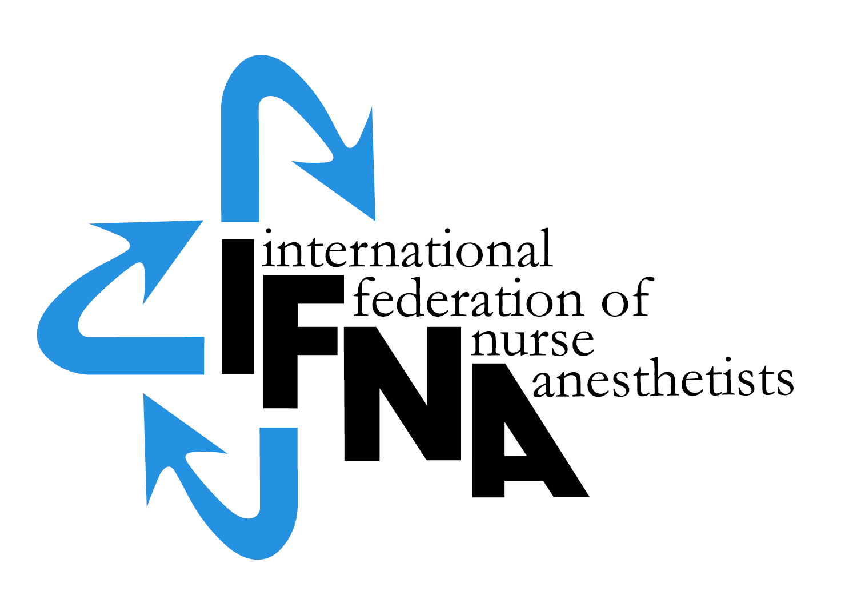

IFNA Accreditation Grant Application

FOR NURSE ANESTHESIA

PROGRAM ACCREDITATION

by the

International Federation of Nurse Anesthetists’ (IFNA)

Education Committee on Behalf of IFNA

Introduction:

The International Federation of Nurse Anesthetists (IFNA) is a global organization representing the specialty of nurse anesthetists. The IFNA Bylaws (Article VII) definition of Nurse Anesthetist is:

“A nurse anesthetist is a person who has completed a program of basic nursing education and a formal and/or actively pursuing a formal basic nurse anesthesia education and is qualified and authorized in his/her country to practice nurse anesthesia”.

The title “nurse anesthetist” may vary from country to country and the IFNA Council of National Representatives (CNR) recognizes that other titles such as: anesthesia nurse, nurse specialist in anesthesia, advanced practice nursing in anesthesia, etc may be used to define the specialty.

IFNA has developed a program approval process with three categories of approval. Programs are to apply for only one category. This application is for Level #3, IFNA Accreditation, which includes a pledge for the program to meet the IFNA Educational Standards for Preparing Nurse Anesthetists to the best of its ability. The program selected for the grant will be asked to submit its curriculum and related material in a written self study for review by the Education Committee. The information will also evaluated by a team of on-site visitors to determine if it meets the Educational Standards.
Following a successful accreditation process, the program’s identity, title of award, and curriculum will be posted on IFNA’s website with a statement that IFNA has reviewed the curriculum, reviewed a self study, conducted an on-site visit to the program and determined the program substantially meets all of the Educational Standards. The website will note that the program has substantially met the Educational Standards as determined by a full review of the program including a written self study and on-site review.
Title of certificate awarded: IFNA Anesthesia Education Program Accreditation.

Instructions:
A copy of IFNA’s Educational Standards for Preparing Nurse Anesthetists and IFNA’s Anesthesia Program Approval Process (APAP) Operational Policies and Procedures are posted on IFNA’s website at www.ifna-int.org. It is strongly recommended that the Educational Standards and policies and procedures be reviewed prior to the completion of this form.

Nurse anesthesia programs applying for accreditation by IFNA are to complete this form. When submitting the form to the IFNA Executive Office, it should be accompanied by appropriate documentation to support what is said about the program in the application. For example, copies of course descriptions should be submitted in support of a written description of the curriculum. The application form requires the name of the Program Director who will be the contact for IFNA in the processing of the application.

It is requested that the completed “IFNA Eligibility Application for Nurse Anesthesia Program Accreditation” form be submitted by e-mail to the IFNA Executive Office at ifna.rod@wanadoo.fr. The following items are to be submitted:

- A completed IFNA Accreditation Grant Application form

- Information about the program’s curriculum as follows:
  - Admission requirements limited to nurses
  - The year the program began and the number of graduating classes where students have graduated from essentially the same curriculum
  - Course Titles
  - Length of Program
  - Degree or certificate awarded to graduates

- A statement that addresses how accreditation will benefit the program.

- A statement that states why the program is not able to pay costs associated with seeking accreditation.
- A pledge by the program that it will cooperate with the IFNA Education Committee in meeting timelines is required.

Please submit all of the items on this list in English by e-mail to the IFNA Executive Office at ifna.rod@wanadoo.fr.

Notification of Eligibility for IFNA Accreditation:
You will be notified if your program is, or is not, selected to participate in the IFNA Accreditation Grant. The selected program will be instructed to start the self-study process in preparation for an on-site visit.

Thank you!

IFNA ACCREDITATION GRANT APPLICATION

Name of Applicant Nurse Anesthesia Program____________________________

Information about the nurse anesthetist Program Director:

Name: ________________________________________________
Title__________________________________________________
Street Address (or P.O. Box) _______________________________
__________________________________________________________________________________________________________
Code: ______________City________________________________
Country_______________________________________________

Telephone: (Country Code, City Code and number)
Home: _____________________________
Work: ______________________________
Fax: (please indicate if number is home or work)
___________________________________
E-mail address: (if available) _______________________

If there is no telephone or fax number, please list a name and number of an alternate contact (include Country Code, City Code and number)
Telephone: _______________________
Fax:___________________________

- IFNA Educational Standards and Program Approval Policies

  - The goal of IFNA’s approval process is to encourage programs to comply with IFNA’s Educational Standards for Preparing Nurse Anesthetists through an approval process that takes cultural differences into consideration. Please review the IFNA Educational Standards for Preparing Nurse Anesthetists and the IFNA Anesthesia Program Approval Process (APAP) Operational Policies and Procedures manual posted on IFNA’s website prior to submitting this application to determine if your program is eligible for accreditation and willing to meet the requirements.

  - Does your nurse anesthesia program (the applicant program) meet requirements to be considered for accreditation?

    - Does the anesthesia program require that students have completed a basic nursing education program of at least 36 months in length prior to admission?
      - Yes____
      - No___

    - Does the anesthesia program require that students have obtained nursing experience of at least one (1) year, preferably in an acute care setting prior to admission?
      - Yes____
      - No___

    - Does your nurse anesthesia program pledge to meet IFNA’s Educational Standards and program approval policies?
      - Yes____
      - No___

    - Has the program been denied registration, recognition or accreditation by a governmental or nongovernmental accreditation or quality assurance entity at any time?
      - Yes____
      - No___

- General Information about Education requirements for Entry into Basic Nursing Education and Practice in your country.

  - Briefly describe the educational and other requirements for entry into basic nursing education in your country.

  - What is the minimum age for entry into a basic nursing educational program? ______

  - What are the number of years (or months) required to successfully complete the basic nursing education?
    - 2 years_____or months______
    - 3 years_____or months______
    - 4 years_____or months______

  - Is licensure required to practice as a professional nurse?
    - Yes____
    - No_____
    - If yes, is this by examination
      - Yes____
      - No____

    - If no, how is the nurse recognized as a professional? (Please check (X) all that apply).
      - The Ministry of Health____
      - The Ministry of Education___
      - Other____

- General information about Nurse Anesthesia Educational Programs and Requirements in your country.

  - Are there other nurse anesthesia education programs in your country?
    - Yes____
    - No____
    - If yes, what is the number of schools? ______

  - Are the programs (Check (X) all that apply.)
    - National____
    - Local_____
    - Regional_____
    - Private____

  - Are the programs (schools) approved?
    - Yes__
    - No___
    - If yes, by whom are they approved?

  - Is the nurse anesthesia educational program’s curriculum standardized throughout the country?
    - Yes___
    - No___

National Nurse Anesthesia Association

Official contact person for national association

Name:

Street Address (or P.O. Box)

City

Country

E-mail address: (if available) _______________________

- Information about your Nurse Anesthesia Program that is applying for IFNA Accreditation (Applicant Program)

  - Briefly describe the educational and other requirements for entry into your nurse anesthesia educational program. This should include: years of nursing experience, type of nursing experience required, pre-entry evaluations, testing, dossier, etc. (Please list all of the requirements).

  - What is the length of your nurse anesthesia educational program?
    - ______years
    - ______months.

  - Who establishes the standards and educational requirements for your nurse anesthesia educational program?

  - Describe the content of your nurse anesthesia educational program, including the amount of theory and clinical experience. Please include an example of the curriculum and a list of course titles.

- Credentials
  - What type of credential is offered upon successful completion of the applicant nurse anesthesia educational program?

    - Certificate_____
    - Diploma_____
    - Degree_____
    - Other_____

  - Is this credential
    - Local______
    - Regional_____
    - National_____

  - Is this credential recognized
    - Yes____
    - No____
    - If yes, by whom is it recognized?

  - Is there a continuing education requirement following completion of the nurse anesthesia educational program?
    - Yes____
    - No____
    - If yes, briefly explain:

Signature & title of authority responsible for the nurse anesthesia program
(Officer in charge):

Signature & title of nurse anesthesia Program Director:

NOTE: Signatures indicate that the program pledges to cooperate with the IFNA Education Committee in meeting deadlines for the IFNA Accreditation Grant.

