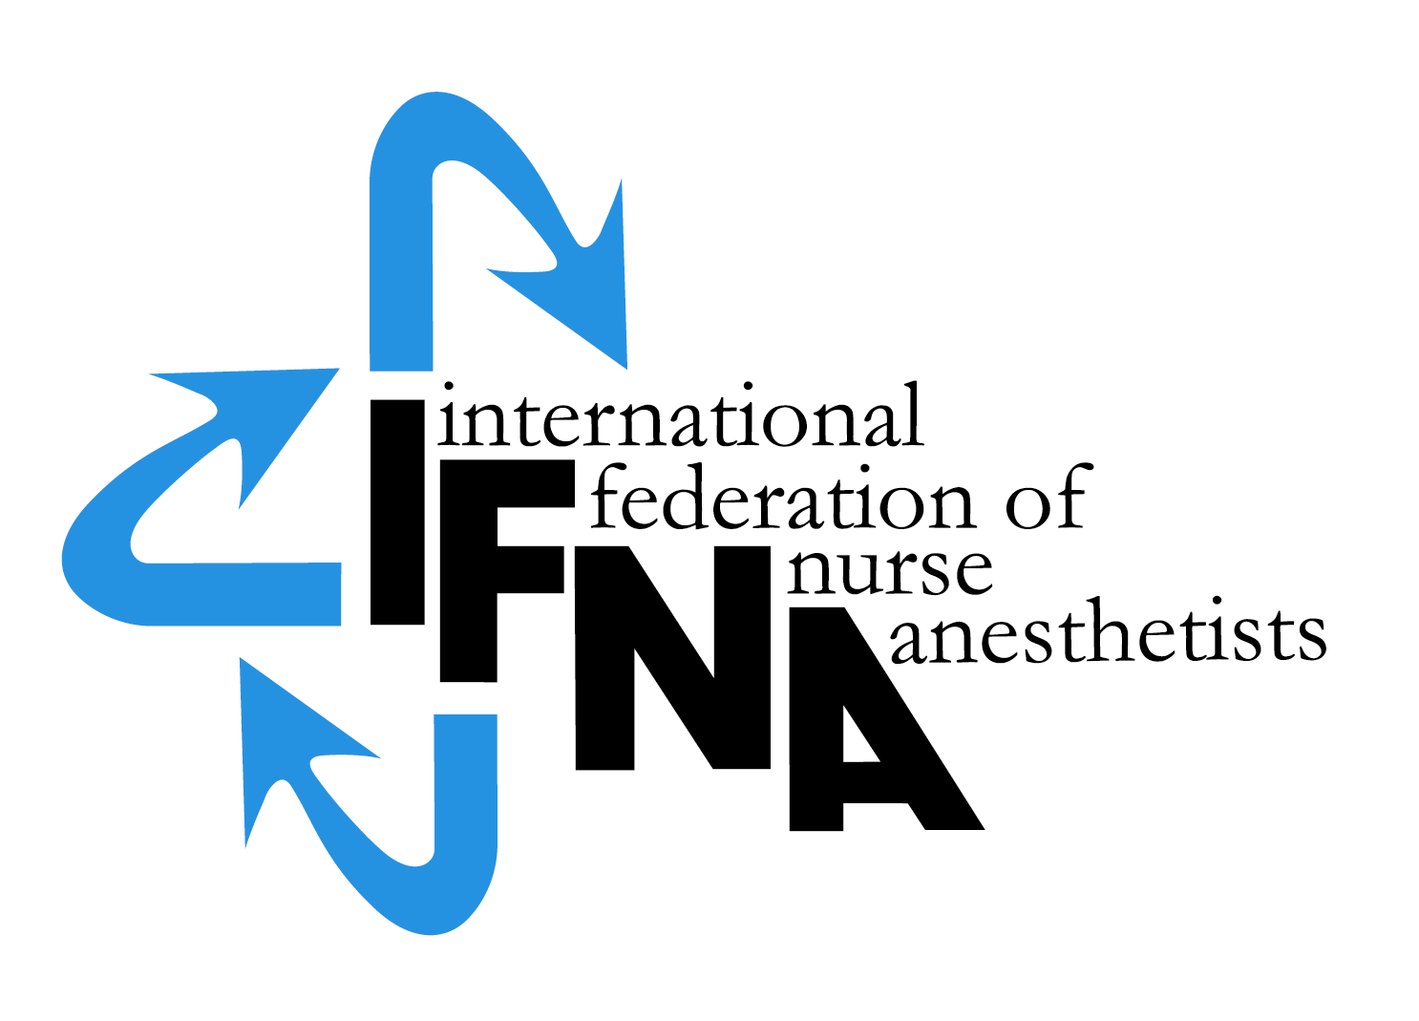

APPLICATION

FOR NURSE - & NON-PHYSICIAN

ANESTHESIA PROGRAM

Level 1 REGISTRATION

Effective: June, 2010
Revised Sept. 2016
Revised June 2018

All rights reserved
© IFNA

Introduction

The International Federation of Nurse Anesthetists (IFNA) is a global organization representing the specialty of nurse anesthetists. IFNA has developed a program approval process with three categories of approval. Programs are to apply for only one category. This application is for IFNA Registration, which includes a pledge for the program to comply with the IFNA Educational Standards for Preparing Nurse Anesthetists to the best of its ability. The pledge includes the signature of the anesthesia program director and the highest institutional official. The program is also required to submit its curriculum. The program’s identity, title of award, and curriculum will be posted on IFNA’s website with a statement that IFNA has not approved the curriculum but it is being posted for information only. Title of certificate awarded: IFNA Anesthesia Education Program Level 1, Registration.

Instructions

A copy of IFNA’s Educational Standards for Preparing Nurse Anesthetists (2016) and IFNA’s Anesthesia Program Approval Process (APAP) Operational Policies and Procedures are available on IFNA’s website at http://ifna.site/ifna-accreditation-program/approval-process-for-nurse-anesthesia-programs/. It is strongly recommended that the Educational Standards and policies and procedures be reviewed prior to the completion of this form.

Anesthesia programs applying for registration by IFNA are to complete this form. When submitting the form to the IFNA Executive Office, it should be accompanied by appropriate documentation to support what is said about the program in the application. For example, copies of course descriptions are to be submitted in support of a written description of the curriculum. The application form requires the name of the Program Director who will be the contact for IFNA in the processing of the application.

It is requested that the completed “IFNA Eligibility Application for Nurse & Non-Physician Anesthesia Program Registration” form be submitted by e-mail to the IFNA Executive Office at IFNA Executive Office at ifna.rod@wanadoo.fr. The following items are to be submitted to apply for IFNA Registration status:

- A completed IFNA Eligibility Application form.

- Information about the program’s curriculum as follows:
  - Admission requirements
  - Course Titles
  - Length of Program
  - Degree or certificate awarded to graduates

- Please submit all of the items on this list to IFNA Executive Office at ifna.rod@wanadoo.fr.

Note to Programs applying for IFNA Registration

You will be notified if your program is, or is not, eligible for IFNA Registration or if additional information is needed.

Thank you!

IFNA ELIGIBILITY APPLICATION FOR

NURSE & NON-PHYSCIAN ANESTHESIA PROGRAM REGISTRATION

Name of Applicant Anesthesia Program____________________________

Information about the Program Director:

Name: ________________________________________________
Title__________________________________________________
Street Address (or P.O. Box) _______________________________
__________________________________________________________________________________________________________
Code: ______________City________________________________
Country_______________________________________________

Telephone: (Country Code, City Code and number)
Home: _____________________________
Work: ______________________________
Fax: (please indicate if number is home or work)
___________________________________
E-mail address: (if available) _______________________

If there is no telephone or fax number, please list a name and number of an alternate contact (include Country Code, City Code and number)
Telephone: _______________________
Fax: __________________________

- IFNA Educational Standards and Program Approval Policies

  - The goal of IFNA’s approval process is to encourage anesthesia programs to comply with IFNA’s Educational Standards for Preparing Nurse Anesthetists through an approval process that takes cultural differences into consideration. Please review the IFNA Educational Standards for Preparing Nurse Anesthetists (2016) and the IFNA Anesthesia Program Approval Process (APAP) Operational Policies and Procedures Manual prior to submitting this application to determine if your program is eligible for registration and willing to meet the requirements.

  - Does your anesthesia program (the applicant program) meet requirements to be considered for registration?

    - Does the anesthesia program only educate non-physicians?
      - Yes____
      - No___

    - How many nurses and other types of students are enrolled in your program?
      - Nurses (#)_____
      - Others (#) _____

    - Does the anesthesia program have admission requirements that include an education in nursing or another scientific background that prepares a student to succeed in the anesthesia program?
      - Yes____
      - No___

iv. Does your anesthesia program pledge to meet IFNA’s Educational Standards and
program approval policies to the best of its ability?
- Yes____
- No___

v. Has the program been denied registration, recognition, or accreditation by a
governmental or nongovernmental recognition or quality assurance entity at any
time?
- Yes____
- No___

- General Information about Education requirements for Entry into Basic Nursing Education and Practice in your country.

  - Briefly describe the educational and other requirements for entry into basic nursing education in your country.

  - What is the minimum age for entry into a basic nursing educational program? ______

  - What are the number of years (or months) required to successfully complete the basic nursing education?
    - 2 years_____or months______
    - 3 years_____or months______
    - 4 years_____or months______

  - Is licensure required to practice as a professional nurse?
    - Yes____
    - No_____
    - If yes, is this by examination
      - Yes____
      - No____
    - If no, how is the nurse recognized as a professional? (Please check (X) all that apply).
      - The Ministry of Health____
      - The Ministry of Education___
      - Other____

- General information about Non-Physician Anesthesia Educational Programs and Requirements in your country.

  - Are there other non-physician anesthesia education programs in your country?
    - Yes____
    - No____
    - If yes, what is the number of schools? ______

  - Are the non-physician programs all recognized
    - National____
    - Local_____
    - Regional_____
    - Private____

  - Are the non-physician programs (schools) approved?
    - Yes__
    - No___
    - If yes, by whom are they approved?

  - Is the non-physician anesthesia educational program’s curriculum standardized throughout the country?
    - Yes___
    - No___

National Association

Is there a national non-physician anesthesia organization in your country?

Yes_____

No_____

Official contact person for national association:
Name: ________________________________________________
Title__________________________________________________
Street Address (or P.O. Box) _______________________________
__________________________________________________________________________________________________________
Code: ______________City________________________________
Country_______________________________________________

Telephone: (Country Code, City Code and number)
Home: _____________________________
Work: ______________________________
Fax: (please indicate if number is home or work)
___________________________________
E-mail address: (if available) _______________________

If there is no telephone or fax number, please list a name and number of an alternate contact (include Country Code, City Code and number)
Telephone: ______________________Fax:__________________________

- Information about your Non-Physician Anesthesia Program that is applying for IFNA Registration (Applicant Program)

  - Briefly describe the educational and other requirements for entry into your anesthesia educational program. This should include: years of nursing or other health professional experience, type of nursing or other experience required, pre-entry evaluations, testing, dossier, etc. (Please list all of the requirements.)

  - What is the length of your anesthesia educational program?
    - ______years
    - ______months.

  - Who establishes the standards and educational requirements for your anesthesia educational program?

  - Describe the content of your anesthesia educational program, including the amount of theory and clinical experience. Please include an example of the curriculum including a list of course titles for posting on IFNA’s website. You can find a sample curriculum in Appendix A and a blank form to fill out in Appendix B of this document.

e. Please explain any differences in the curriculum for nurse and non-nurse students.

- Credentials
  - What type of credential is offered upon successful completion of the anesthesia educational program?

    - Certificate_____
    - Diploma_____
    - Degree_____
    - Other_____

  - Is this credential
    - Local______
    - Regional_____
    - National_____

  - Is this credential recognized
    - Yes____
    - No____
    - If yes, by whom is it recognized?

  - Is there a continuing education requirement following completion of the non-physician anesthesia educational program?
    - Yes____
    - No____
    - If yes, briefly explain:

We are applying for IFNA Registration

We have read and understand the definition of IFNA Registration and have decided to submit the program’s curriculum and related material to the IFNA Education Committee. We understand that the curriculum will be posted on IFNA’s website if the program is found eligible for registration. We pledge to meet the IFNA Educational Standards for Preparing Nurse Anesthetists to the best of our ability.

In addition, the program has not been denied recognition or accreditation by a governmental or nongovernmental accreditation or quality assurance entity.

___________________________________________________________
Signature & title of Program Director Date

___________________________________________________________
Signature & title of highest institutional official Date

Appendix A

SAMPLE Curriculum Format

Official name of nurse anesthesia program
Name of program director:
Title:
Mailing address
Country
CURRICULUM OVERVIEW

Degree Awarded: Master of Science in Nursing with a Specialization in Nurse Anesthesia

Term and Course Credits
Fall (16)
NURS 5010 Graduate Anatomy 5
NURS 5001 Graduate Physiology 4
NURS 5700 Basic Principles of Anesthesia w/Equipment & Technology #1 1
NURS 5710 Chemistry & Physics Applied to Anesthesia 3
NURS 5711 Pharmacology related to Anesthesia 3

Spring (15)
NURS 5101 Advanced Pathophysiology 3
NURS 5109 Advanced Pharmacology 3
NURS 5701 Basic Principles of Anesthesia #2 3
NURS 5715 Advanced Health Assessment for Nurse Anesthesia 3
NURS 5240 Statistics & Epidemiology for Advanced Practice 3

Summer (12)
NURS 5250 EBP & Research Methods 3
NURS 5215 Health Promotion in Individuals & Vulnerable Populations 3
NURS 5702 Advanced Principles of Anesthesia #1 3
NURS 5730 Clinical Experience I (OR on W/Th/F) 3

Fall (12)
NURS 5910 Research & Theory Integration 3
NURS 5223 Health Care Policy & Ethics 3
NURS 5703 Advanced Principles of Anesthesia #2 3
NURS 5731 Clinical Experience II (OR on W/Th/F) 3

Spring (10)
NURS 5228 Organization & Systems Leadership 3
NURS 5720 Professional Aspects of Nurse Anesthesia 3
NURS 5732 Clinical Experience III (OR on T/W/Th/F) 4

Summer (6.5)
NURS 5740 Clinical Correlation Conferences 1.5
NURS 5733 Clinical Experience IV (OR on M/T/W/Th/F) 5

Fall (6.5)
NURS 5741 Clinical Correlation Conferences 1.5
NURS 5734 Clinical Experience V (OR on M/T/W/Th/F) 5

Total Credit Hours 78

Note: The formula for converting credit hours to contact hours in this sample curriculum is 1 credit = 1 contact hour per week for 15 weeks per semester (78 x 15 = 1,170 contact hours). This academic unit of measurement will vary among countries. Please use the recognized credit or contact hours for the applicant program.

Appendix B
Official Name of the Nurse Anesthesia Program:
Name of program director:
Title:
Mailing address
Country

Curriculum Overview
Degree/ Diploma / Certificate awarded:

Term / Course title hours / credits
Semester

Clinical Hours

Curriculum overview courtesy of B. Henrichs, Goldfarb School of Nursing at Barnes-Jewish College, Nurse Anesthesia Program, St. Louis, Missouri, USA

